

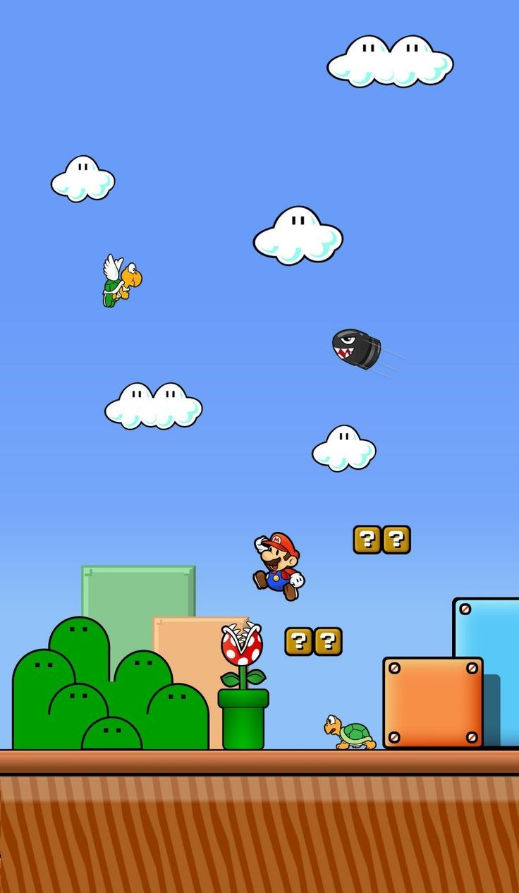

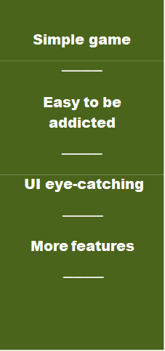

MARIO

FINAL PROJECT OOP

*HomiesHCMIU*

Mario is one of the most classic and iconic video games in history, developed by Nintendo. The game revolves around Mario, a brave plumber who often teams up with his brother Luigi on a journey to rescue Princess Peach from Browser, the king of the evil turtles.

CHAPTER 1: 14

INTRODUCTION 14

**1.1** **Gaming in the Field:** 14

**1.2** **About the game project:** 14

**1.3** **Our Mario game:** 15

**1.4** **References:** 15

**1.5** **Developer Team:** 15

CHAPTER 2: 17

SOFTWARE REQUIREMENTS 17

**2.1** **Developer Team:** 17

**2.2** **Working tools:** 17

**2.3** **Use Case Scenario:** 18

**2.4** **Use Case diagram:** 19

**2.5** **Class diagram:** 20

**Images Control Diagram** 20

**UI Diagram** 21

**Condition methods Diagram** 23

**Entities Diagram** 24

**Levels Diagram** 25

**Audio Diagram** 26

**Main** 27

CHAPTER 3: 28

**A.** **Project Structure:** 28

**B.** **Project Demo:** 30

**1.** **Main theme:** 30

**2.** **Game loop:** 30

**3.** **Load Mario and enemies animation:** 32

**3.1** **Entity class (parent class of Player and enemies)** 33

**3.1.1 Class declaration, attribute, and constructor** 33

**3.1.2 Methods in entity** 33

**3.2** **Load Mario:** 34

**3.2.1** **Mario load animation image:** 34

**3.2.2** **Update Mario animation:** 37

**3.3** **Enemies Animations:** 41

**3.3.1** **GetTurtle(EnemyManager enemyManager):** 41

**3.3.2** **GetMushroom():** 42

**3.3.3** **GetJoker():** 44

**3.3.4** **How to load Enemies and draw Image of each type.** 45

**3.3.5** **Draw Method:** 48

**3.3.6** **Update Method:** 48

**3.3.7** **addEnemies Method and Constructor:** 49

**3.3.8** **Class variables:** 50

**3.4** **Enemies type and state:** 51

**4.Why enemy is the abstract class?** 54

**4.1** **Class Variables and Constructor:** 54

**4.2** **Methods of Enemy:** 55

**5. Turtle, Mushroom, Joker class:** 59

**5.1** **Class Turtle:** 59

**5.1.1** **Variables and constructor in Turtle:** 59

**5.1.2** **Movement and behavior:** 61

**5.2** **Class Mushroom:** 63

**5.2.1** **Constructor in Turtle:** 63

**5.2.2** **Movement of mushroom:** 64

**5.3** **Class Joker:** 65

**5.3.3** **Constructor in Joker:** 65

**6.** **Level:** 66

**6.1** **Game constant:** 66

**6.2** **Game constant:** 67

**6.3** **Draw levelData:** 69

**7.Collision:** 70

**7.1** **HelpMethods:** 70

**7.1.1** **isSolid:** 70

**7.1.2** **canMoveHere:** 71

**7.1.3** **GetEntityXPosNextToWall:** 72

**7.1.4** **GetEntityYPosUnderRootOrAboveFloor:** 73

**7.1.5** **isEntityOnFloor and isOnFloor:** 74

**7.1.6** **nextToWall:** 75

**7.1.7** **playerCollisionAboveEnemies:** 76

**8.** **Update player position and gravity:** 77

**8.1** **Horizontal Movement Handling:** 78

**8.2** **Airborne State Management:** 79

**8.3** **Vertical Movement Handling (Airborne Logic):** 79

**8.4** **Horizontal Movement on Ground:** 79

**9.** **Sound:** 80

**9.1** **Sound package:** 80

**9.2** **audio package:** 80

**10.** **Menu:** 89

**10.1** **Main Menu:** 89

**10.2** **Main Menu:** 91

**10.3** **Let’s play:** 92

**10.3.1** **Death screem:** 93

**10.3.2** **Pause screen:** 94

**10.3.3** **Victory screen:** 96

CHAPTER 4: 99

TASK ALLOCATION & CONTRIBUTION 99

**4.1** **CONTRIBUTION** 99

**Contribution** 99

**4.2** **TASK ALLOCATION** 99

- END - 101

# CHAPTER 1:

# INTRODUCTION

1. **Gaming in the Field:**

In the rocket growing field of software engineering and development, video game creation stands out as unique technology, art and innovation. Video game development included multiple disciplines, such as graph design, sound engineering, storytelling, and programming. To create an engaging gameplay, continuous prototyping and refinement are requirements.

As part of our “Objected Oriented Programming” (OOP) subject is a four - credit course and as part of our degree, we chose Mario-style game. This project allows us to apply and enhance our Java programming, practice the OOP concepts learned in class (e.g., inheritance, polymorphism, and design patterns), and gain a hands-on understanding of the complete game development lifecycle.

1. **About the game project:**

There are many Mario-inspired games available on various platforms, including mobile apps, and web games.

Our team has remade a Mario-style game with a fresher interface, added new features and enhanced level design.

In summary, our goal is to create a more engaging and user-friendly game that retains player interest and encourages loyalty. This project allows us to combine creativity with technical skills, delivering a fresh take on the classic Mario gameplay.

1. **Our Mario game:**

As mentioned, we add more features and challenges to our Mario game to make the User get more excited while enjoying the game.

So firstly, we have the basic rule is find the fastest way to touch the flag at the end of map.

Then, we add some features to the game:

* Sounds and animation to make the game more attractive.
* Apply Stack, singleton pattern, adapter pattern and some other OOP skills.

1. **References:**

* Images from: Tutorial Android App Development for Beginner   
  [**https://youtube.com/playlist?list=PL4rzdwizLaxYmltJQRjq18a9gsSyEQQ-0&si=fgXbYVoRFUozo04d**](https://youtube.com/playlist?list=PL4rzdwizLaxYmltJQRjq18a9gsSyEQQ-0&si=fgXbYVoRFUozo04d)
* Soundform: [**https://themushroomkingdom.net/media/smb/wav**](https://themushroomkingdom.net/media/smb/wav)

1. **Developer Team:**

Homies team is a Data Structure Algorithm project team. We have 4 members come from International University, Computer Science major:

|  |  |  |
| --- | --- | --- |
| **Name**  **GitHub username** | **UID** | **Contribute** |
| Nguyễn Tấn Khánh  [*TanjiKhanh*](https://github.com/TanjiKhanh) | ITCSIU23014 | * Write report * Shopping activity * Draw class diagram |
| Lê Hoàng Khanh  [*Khanh-per*](https://github.com/Khanh-per) | ITCSIU23013 | * Write report * Design Motion event * Support main function of * Handle Game |
| Nguyễn Quang Huy  [*QuangHuy-68*](https://github.com/QuangHuy-68) | ITDSIU23038 | * Write report * Design UI and effect Write * Menu Activity |
| Phạm Trung Kiên  [*Nobodywinsbutme*](https://github.com/Nobodywinsbutme) | ITCSIU23020 | * Write report * Draw class diagram * Design UI and effect Write * Menu Activity |

# CHAPTER 2:

# SOFTWARE REQUIREMENTS

1. **Developer Team:**

**GIMP - GNU Image Manipulation Program:** GIMP is a free and open source image editing software, available on many operating systems such as GNU/Linux, macOS, and Windows. It provides powerful tools for photo editing, freehand drawing, background removal, blurring, and adding artistic text.

1. **Working tools:**

* **IntelliJ IDEA and Visual Studio Code**: an integrated development environment, to streamline the development process by providing code editing, build automation, and debugging functionalities.
* **GITHUB:** Multiple developers can work on a project simultaneously, using features like pull requests, branches, and code reviews to coordinate and ensure code quality.

1. **Use Case Scenario:**

We have created the use cases based on the UX view of the game.

|  |  |  |
| --- | --- | --- |
| Mario | PLAY | Play the game |
| Options the game |
| Exit the game |

1. **Use Case diagram:**

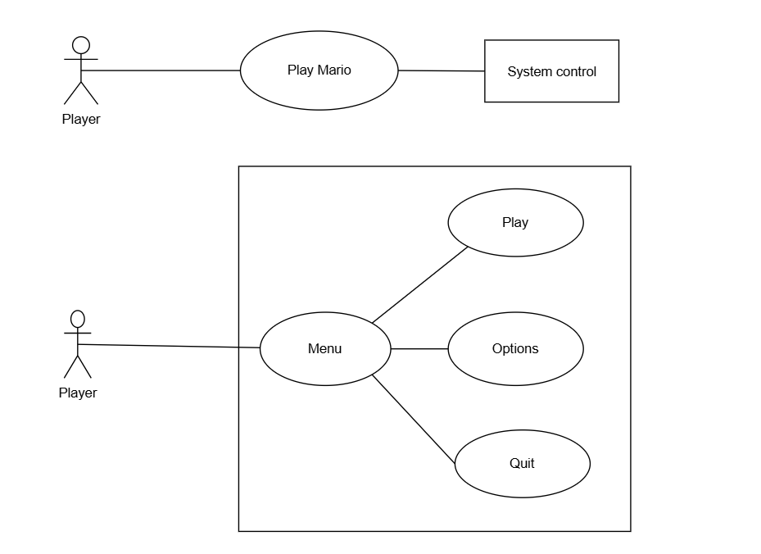

1. **Class diagram:**

* **Link UML:** [**https://drive.google.com/file/d/1CbgsbBmJicND73D81AOIpRNdMDpaSvlL/view**](https://drive.google.com/file/d/1CbgsbBmJicND73D81AOIpRNdMDpaSvlL/view)

### **Images Control Diagram**

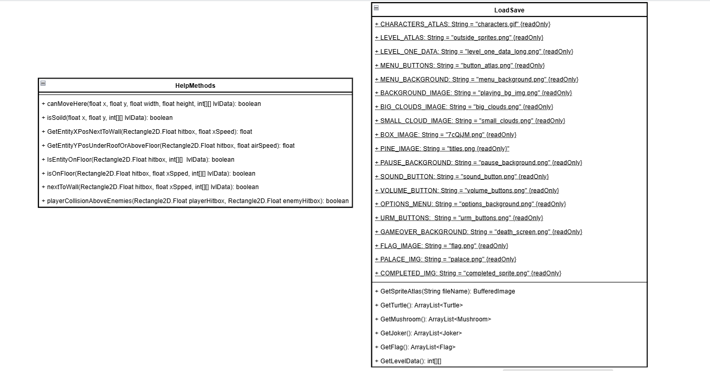

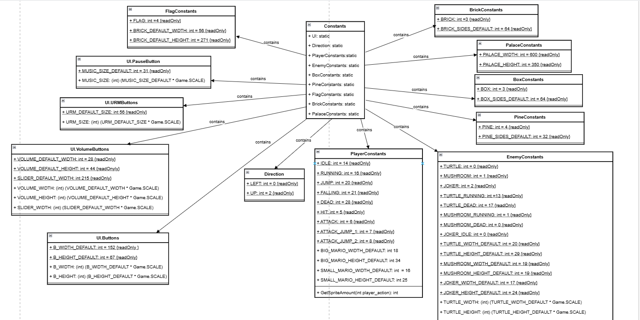

**UI Diagram**

**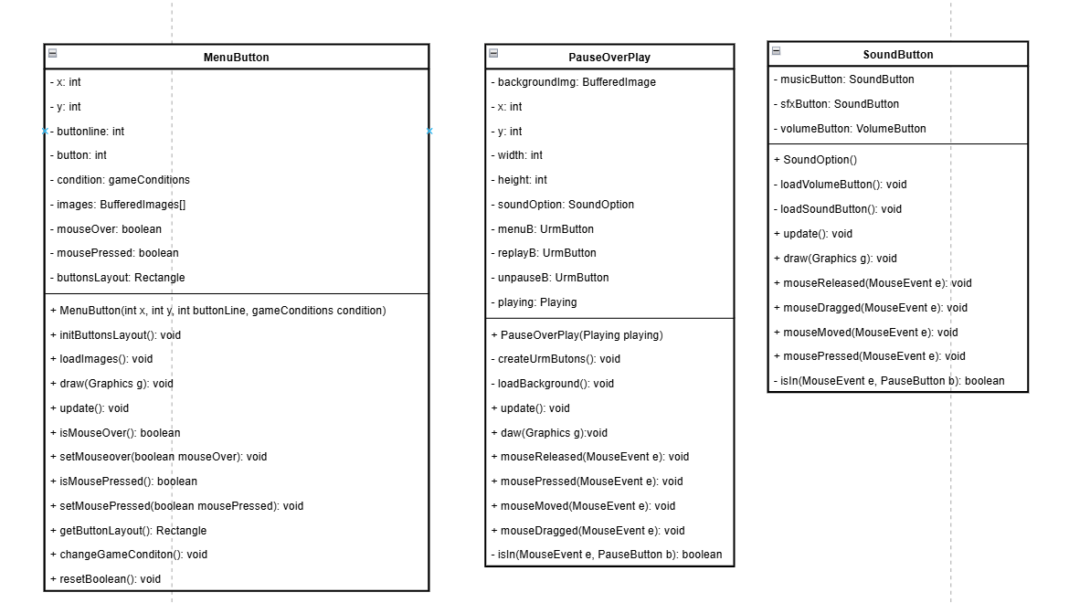  
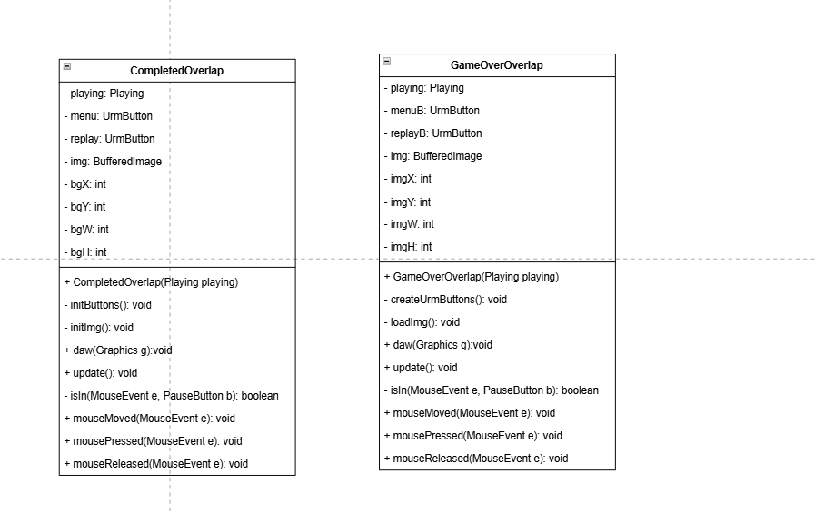  
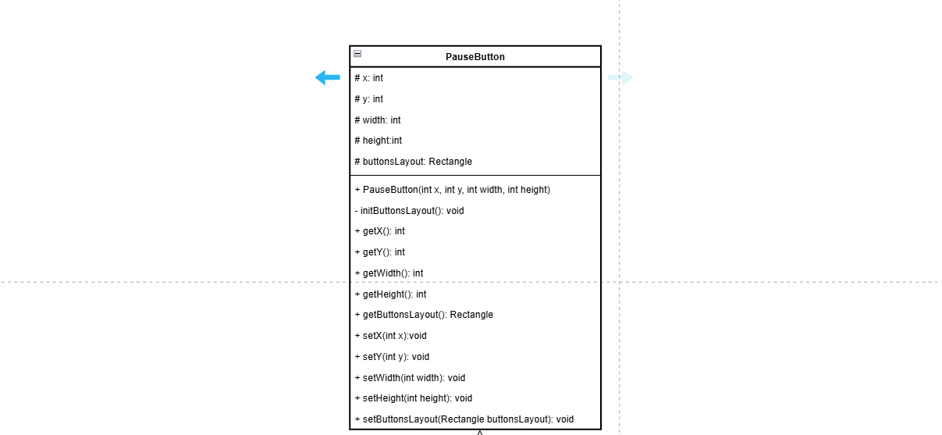  
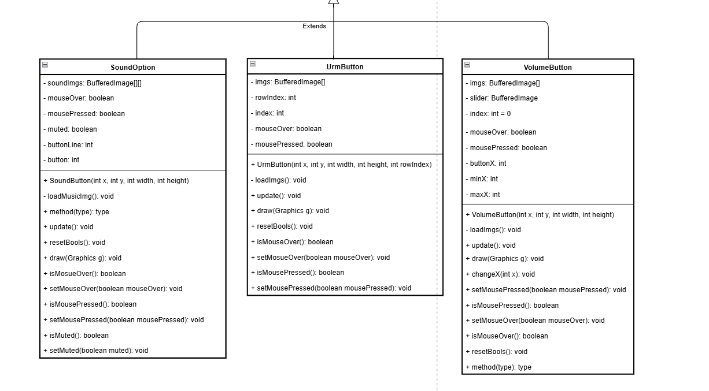**

**Condition methods Diagram**

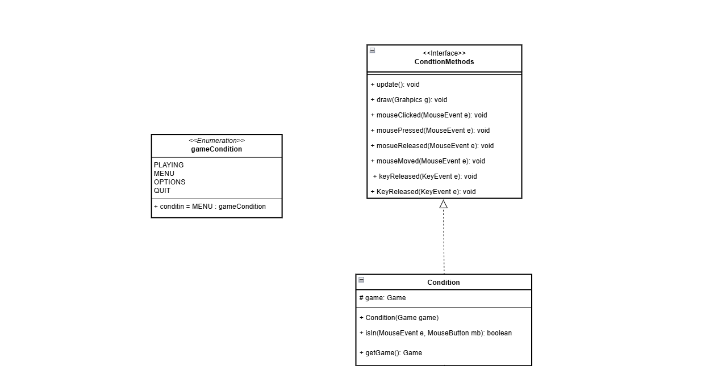

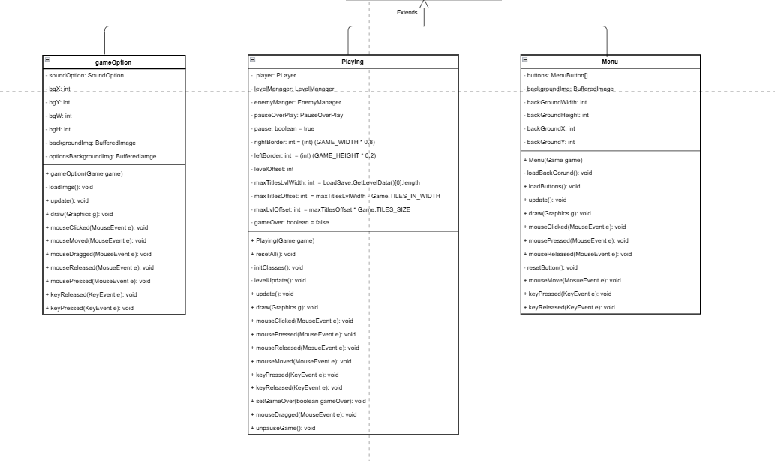

**Entities Diagram**



**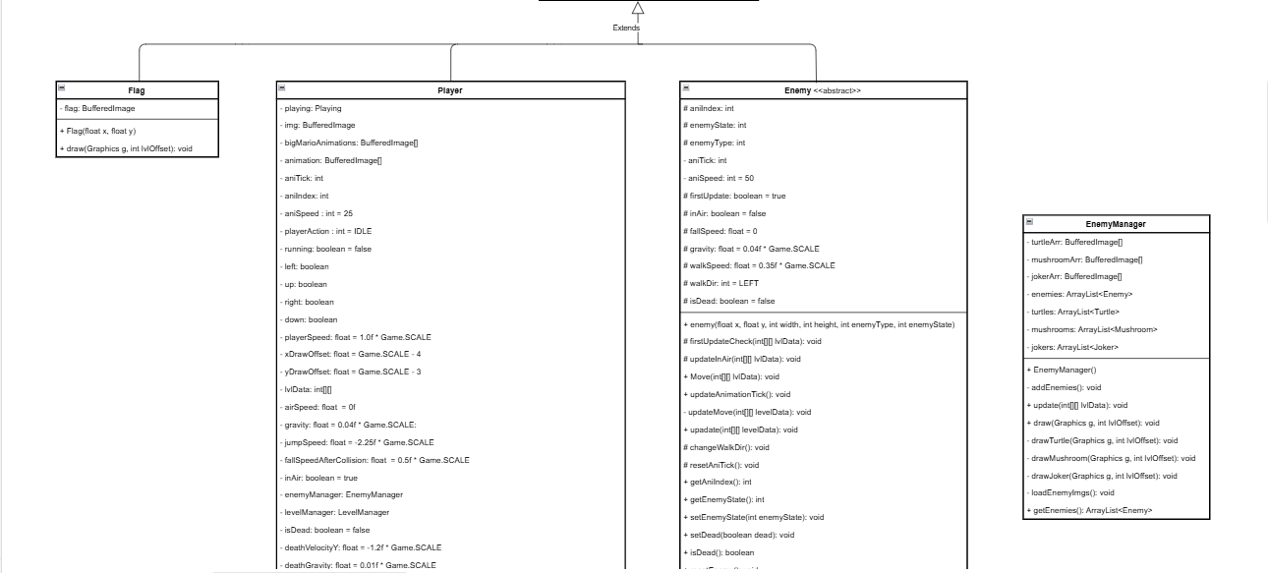  
  
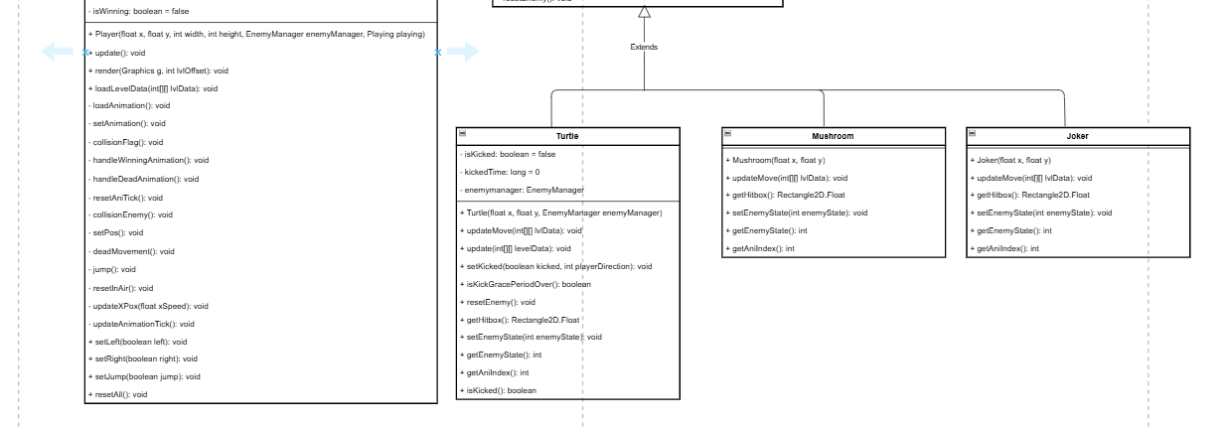**

**Levels Diagram**

**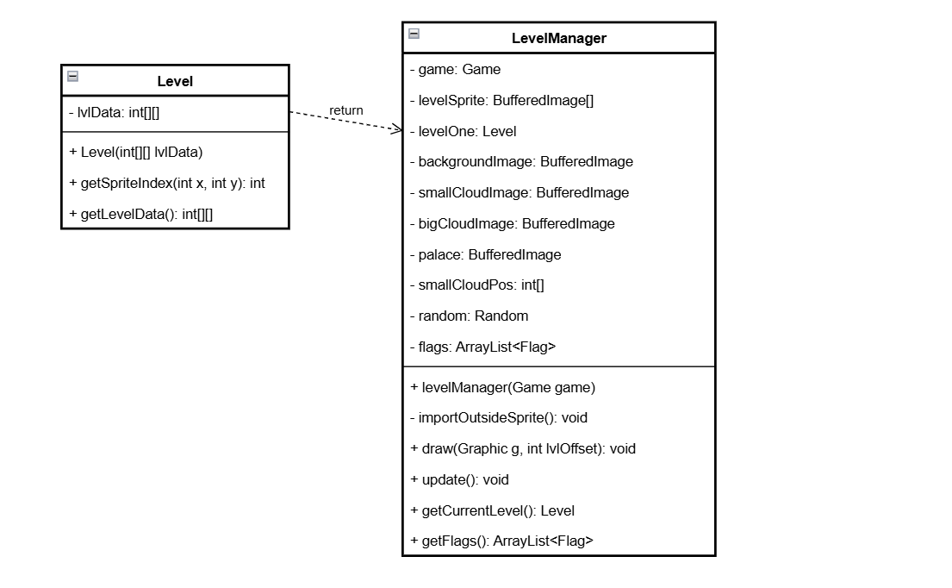  
Audio Diagram**

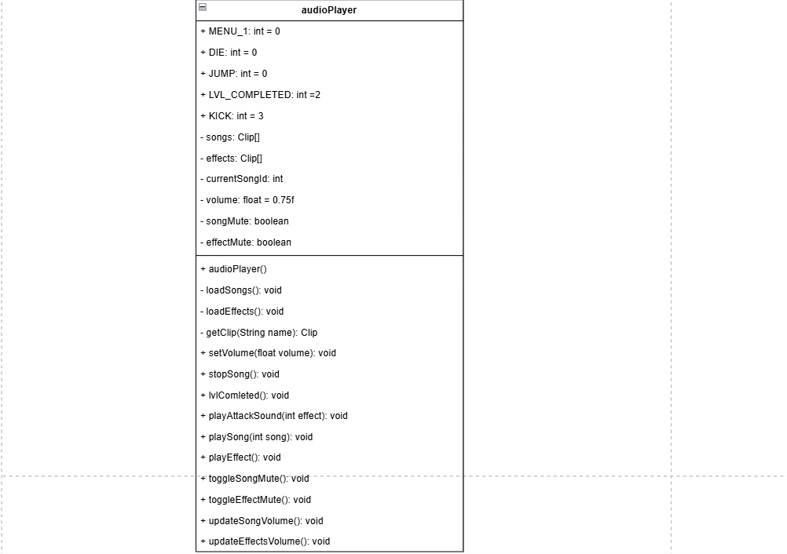

**Main**

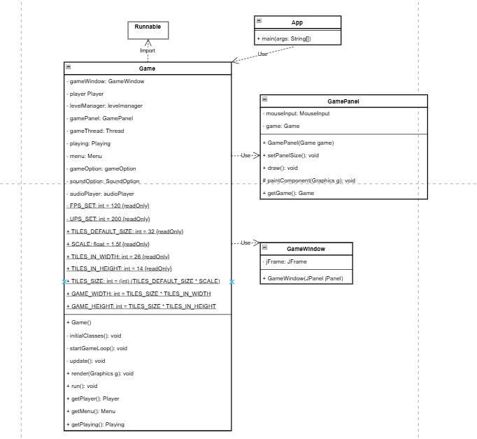

# CHAPTER 3:

DESIGN &

IMPLEMENTATION

1. **Project Structure:**

**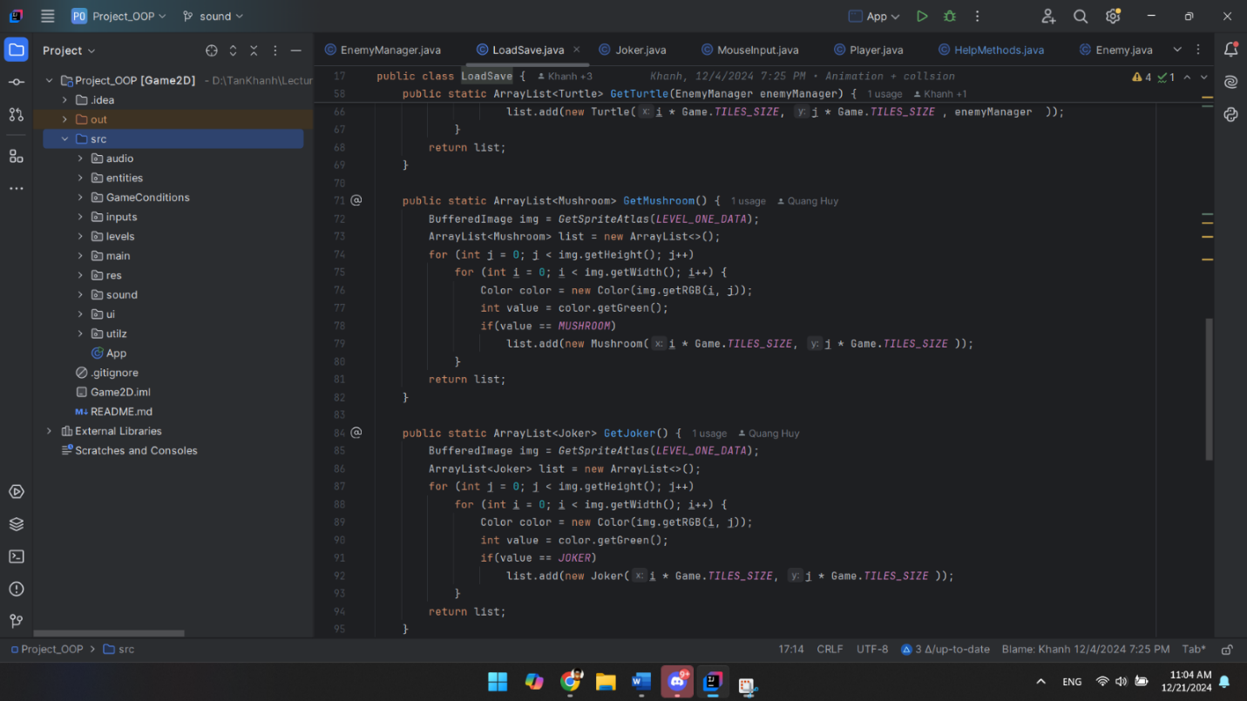  
Figure 4.1: Project Structure**

* **audio:** contains classes related to sound or audio processing in the project, such as sound
* **entities:** this folder contains classes representing game objects or characters, such as players, enemies...
* **gameConditions:** could include classes that define rules, win/loss conditions, or other gameplay logic.
* **inputs:** likely contains classes for handling user input, such as keyboard or mouse events.
* **levels:** This folder manages the structure, data, or logic of different game levels.
* **main:** contains the main entry point for the project (e.g., a class with the main method). It may also include general game logic or initialization.

* **res:** short for "resources," this folder holds non-core assets like images, configuration files, or data files.
* **sound:** similar to audio, but this might store audio resources like .wav or .mp3 files directly.
* **ui:** includes classes for designing the game's graphical user interface, such as menus or HUD elements.
* **utilz**: A utility folder where helper classes or commonly used methods are stored, such as math utilities or file operations.

1. **Project Demo:**
   1. **Main theme:**

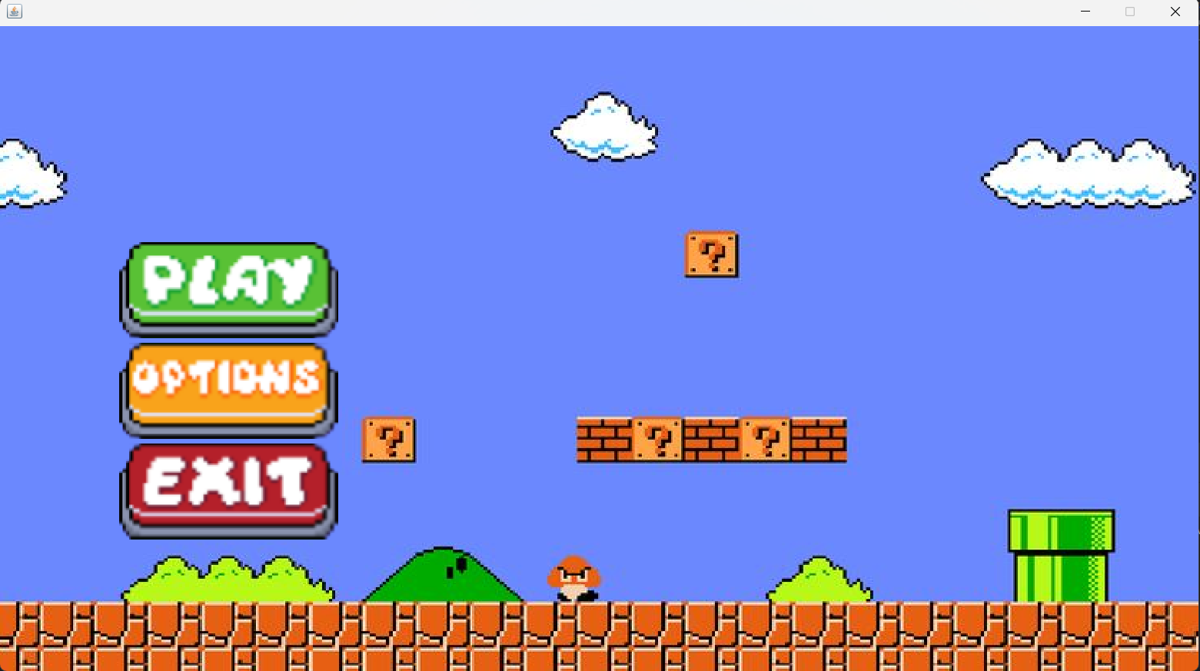

* 1. **Game loop:**
* The game loop is the core of a game’s logic. It ensures that the game runs smoothly by continuously updating the game state and rendering the graphics. In your implementation, the game loop is executed in the run method of the Game class, and here's how it works step by step.
* **Key Variables**
  + **FPS_SET (Frames Per Second):**
    - Controls how often the game is rendered (visual updates).
    - In your code, it is set to 120, meaning the game tries to render 120 frames per second.

* + **UPS_SET (Updates Per Second):**
    - Controls how often the game updates its logic (e.g., player movement, physics, etc.).
    - Set to 200, meaning the game state is updated 200 times per second.

* + **Time-related Variables:**

* + - timePerFrame: How much time (in nanoseconds) each frame should take for 120 FPS (1 second ÷ FPS).
    - timePerUpdate: How much time each update should take for 200 UPS.
    - deltaF & deltaU: Track the time left for rendering and updating, respectively.
    - previousTime, currentTime: Measure elapsed time.

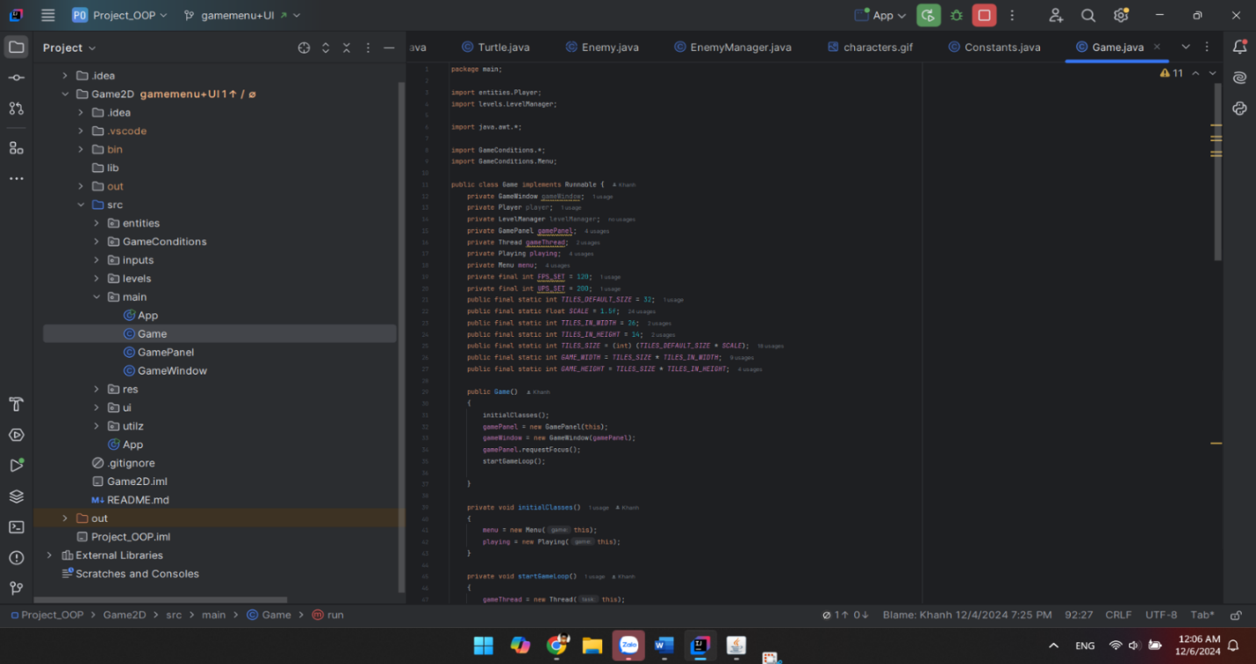

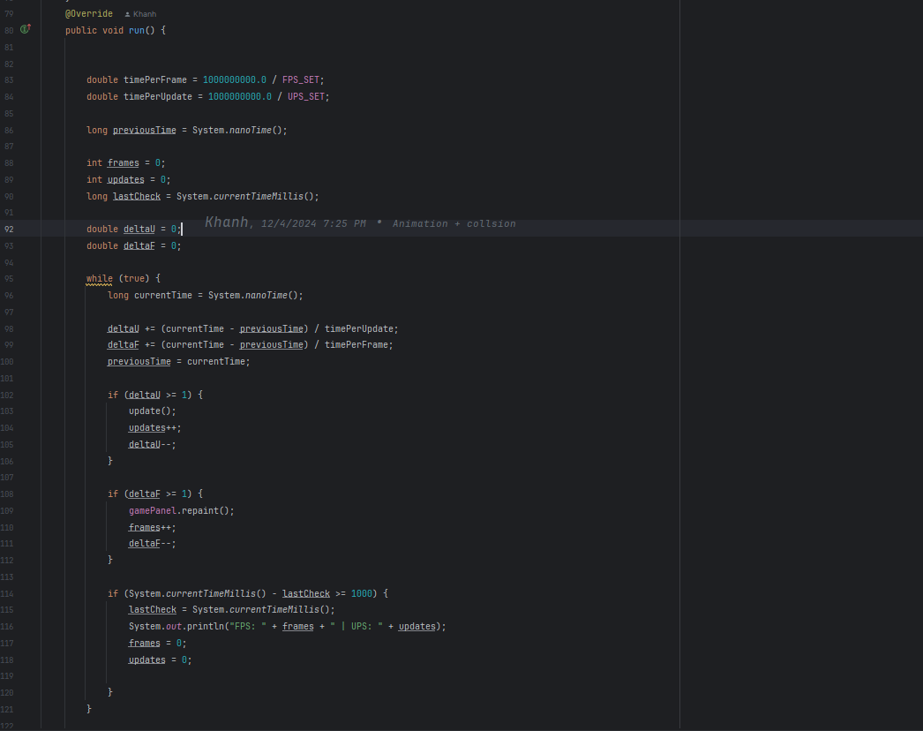

* 1. **Load Mario and enemies animation:**

1. **Entity class (parent class of Player and enemies)**

##### **3.1.1 Class declaration, attribute, and constructor**

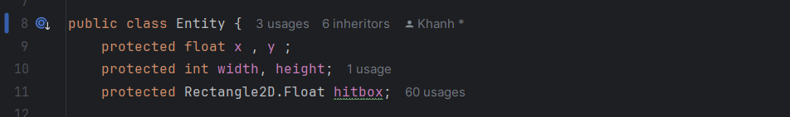

* **protected**: The x, y, width, height, and hitbox attributes are accessible within this class and by its subclasses.
* **x**, **y**: Floating-point coordinates representing the position of the entity.
* **width**, **height**: Integer dimensions of the entity.
* **hitbox**: **A Rectangle2D.Float** object defining a rectangular boundary around the entity, used for collision detection.

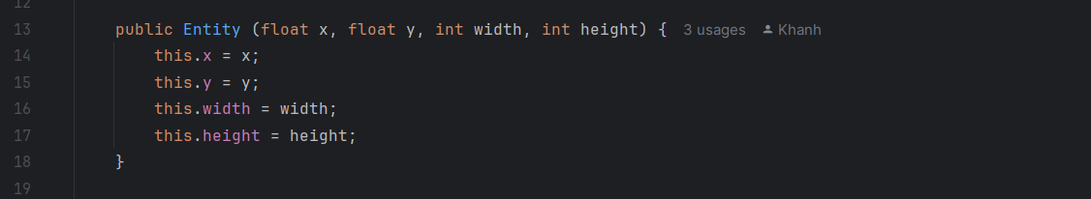

* Initializes an **Entity** object with **position** (x, y) and **dimensions** (width, height).
* The “**this”** keyword differentiates class attributes from the constructor parameters.

##### **3.1.2 Methods in entity**

* + **Initialize Hitbox.**

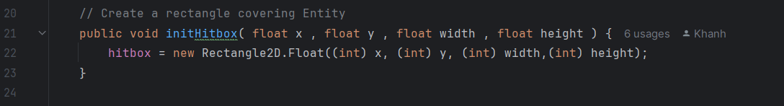

* **Parameters:**
* **x**, **y**: The starting position of the hitbox.
* **width**, **height**: The dimensions of the hitbox..
* Why hitboxes?

+ **Hitboxes** are essential for detecting interactions, such as collisions with other entities or boundaries within the game

* **Draw Hitbox**

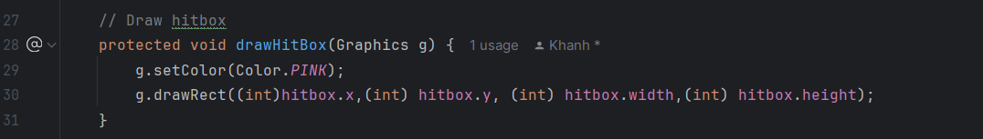

* Sets the drawing color to pink using g.setColor(Color.PINK).
* Draws the rectangle (hitbox) using g.drawRect. The parameters are cast to int for rendering purposes.

1. **Load Mario:**
   * 1. **Mario load animation image:**

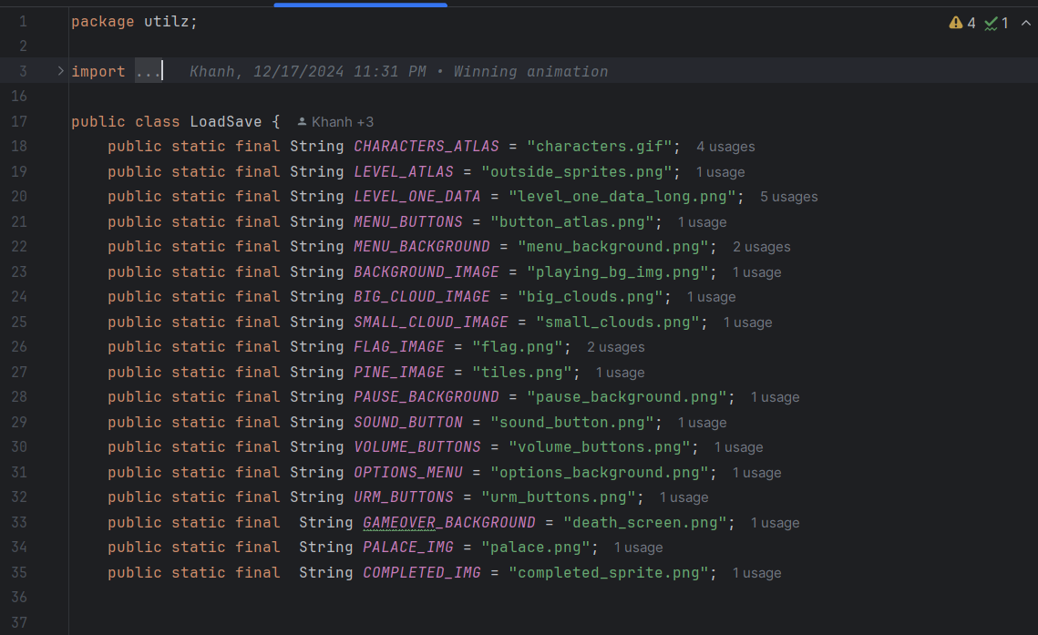

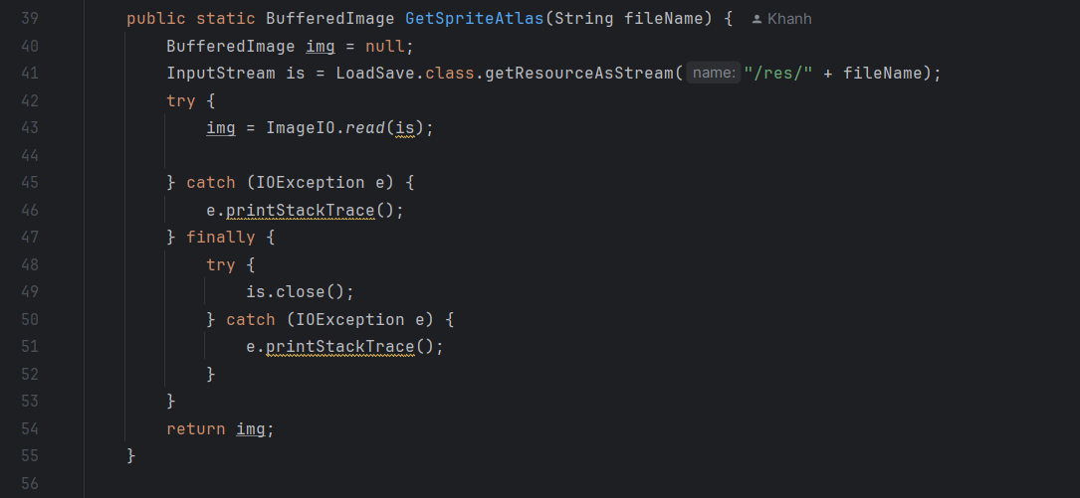

* GetSpriteAtlas function is to load image of all animations to private bufferImage img of Player class.

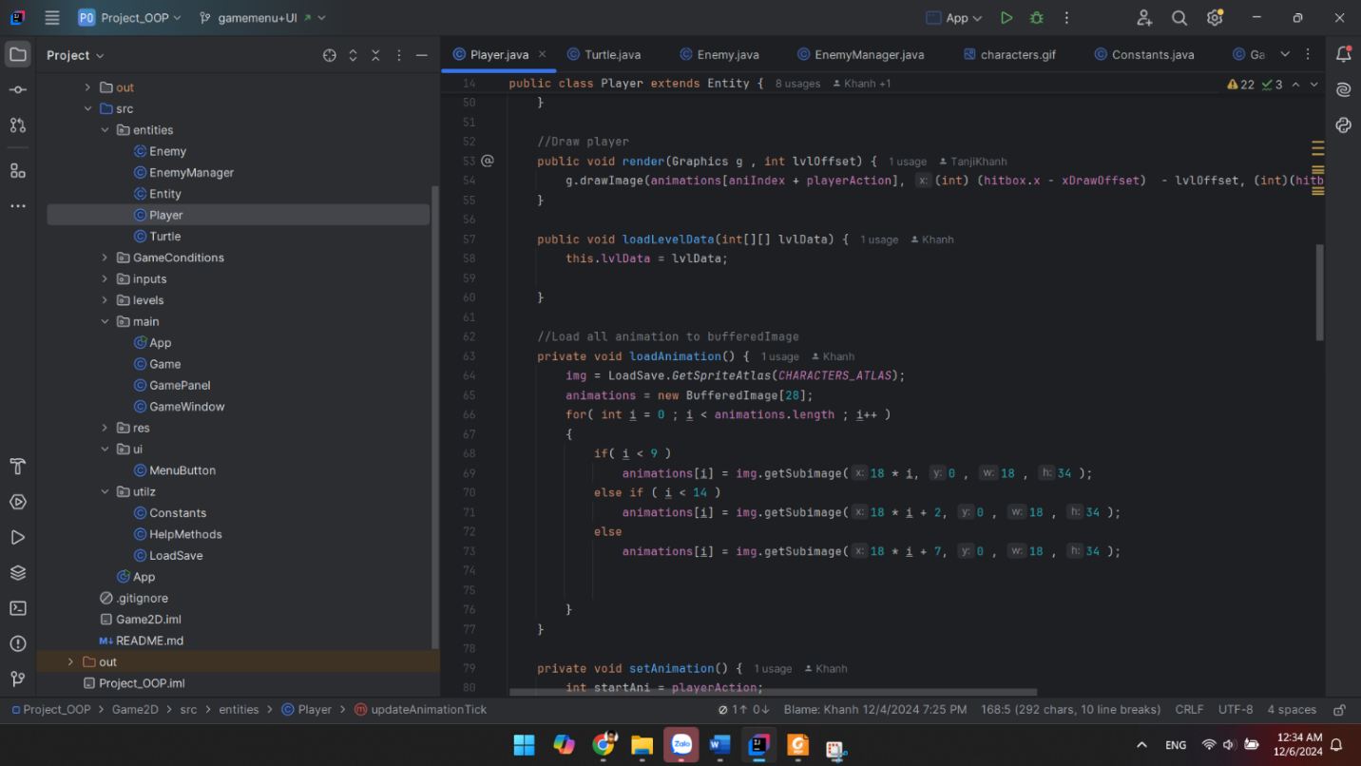

* BufferImage animation stores all animation separated from image.

* The function loadAnimation dynamically extracts frames for the "Big Mario" character's animations from a sprite sheet, handling variations in the layout of frames on the sheet. This makes it easy to use these frames for rendering animations in the game.

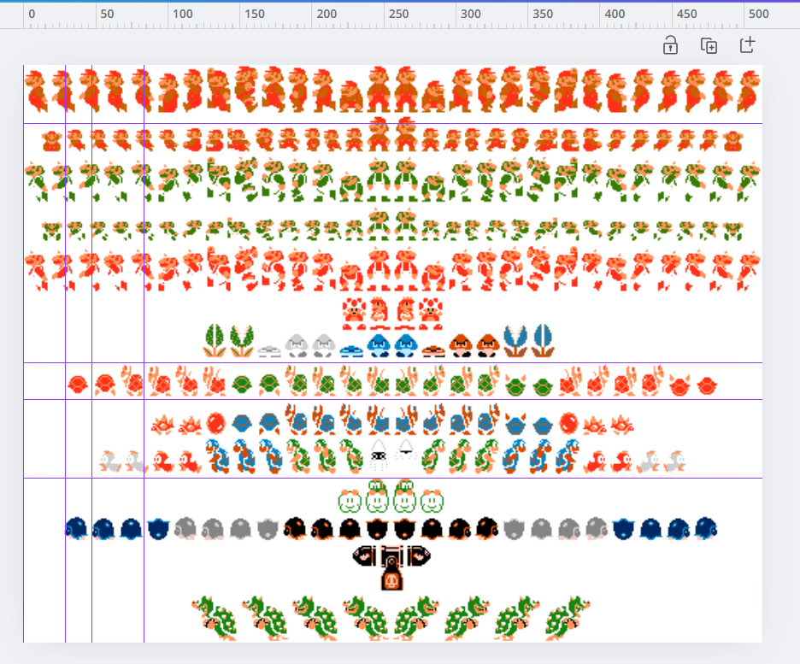

* + 1. **Update Mario animation:**

**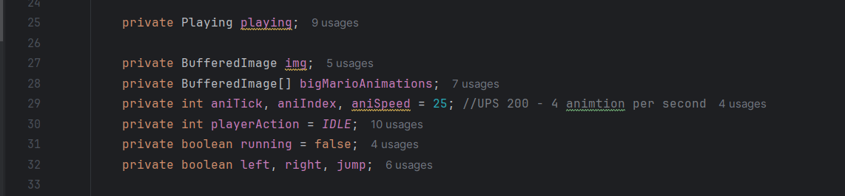  
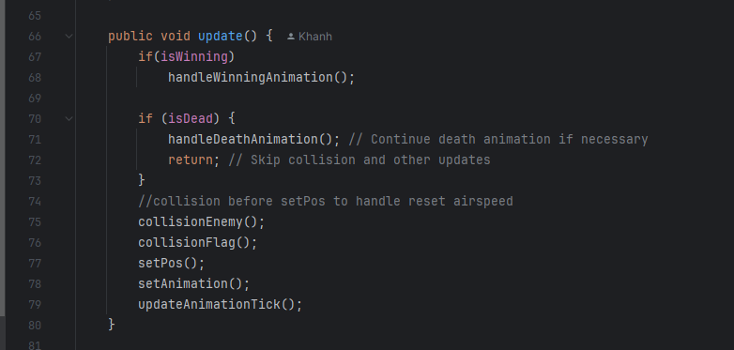**

* **In setPos function:**
  + If the player presses the A (left) key, xSpeed decreases by playerSpeed.
  + If the player presses the D (right) key, xSpeed increases by playerSpeed.
  + Flag running set to true.

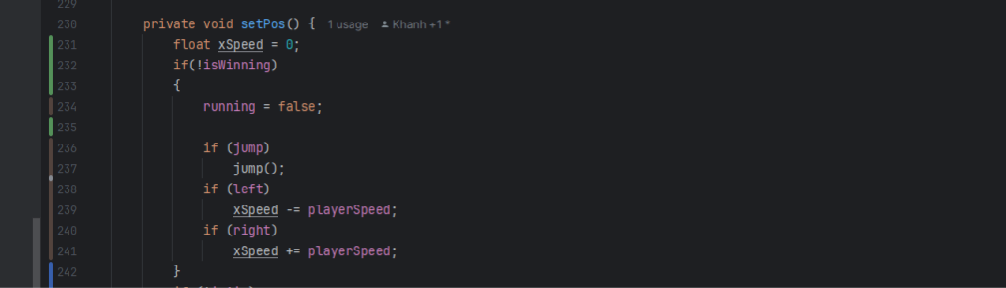

* **In setAnimation function:**
  + If running is true set player Action = running.
  + RUNNING and IDLE constant variable store the position of specific animation in the animation array bufferImage.

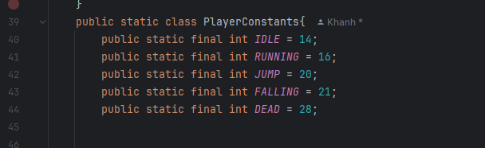

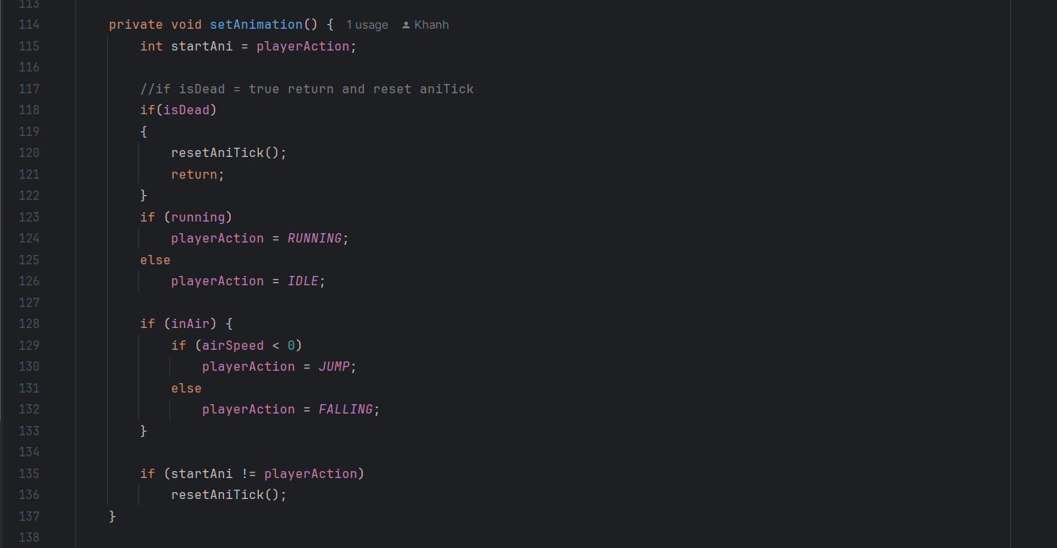

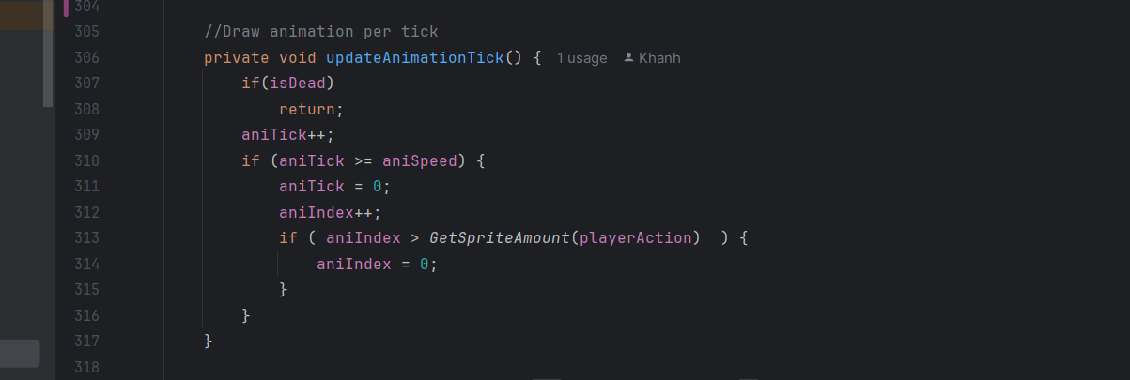

* **In updateAnimationPerTick function:**
  + Increment the animation tick (aniTick).
  + If the tick count exceeds the frame speed (aniSpeed) reset the tick and move to the next frame.
  + Looping animation: if the frame index exceeds the sprite count for the current action (GetSpriteAmount(playerAction)reset aniIndex to 0.
  + GetSpriteAmount funcion is return how many frame of animation that action have.
  + For example, running animation have 3 frames.

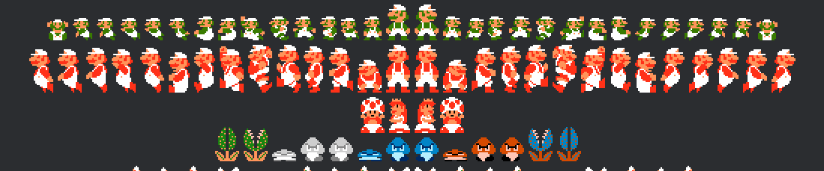

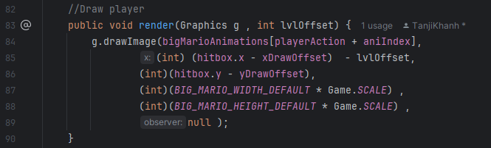

* 1. **Enemies Animations:**
     1. **GetTurtle(EnemyManager enemyManager):**

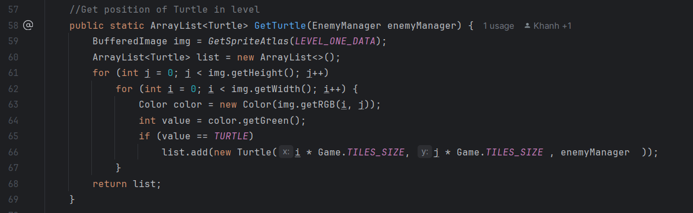

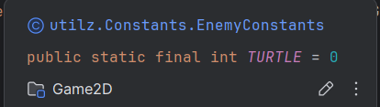

* **Purpose:** Finds all the Turtle objects in the level and returns their positions as an ArrayList.
* **Parameters:**
  + **EnemyManager enemyManager**: Used to initialize the Turtle object (possibly for managing enemy behavior or state in the game).
* **Steps:**
  + Load the level data image using the GetSpriteAtlas method (line 60).
  + Iterate through each pixel in the image (line 61 - 67):
    - Pixel Color: Extract the green component of the pixel's RGB value.
    - Check if the green value equals the predefined TURTLE constant = 0(line 64 - 65).
  + If a match is found:

* + - Create a Turtle object with its position calculated from the pixel's coordinates (i * Game.TILES_SIZE, j * Game.TILES_SIZE)( line 66).
    - Add the Turtle object to the list.
  + Return the list of Turtle objects.
    1. **GetMushroom():**

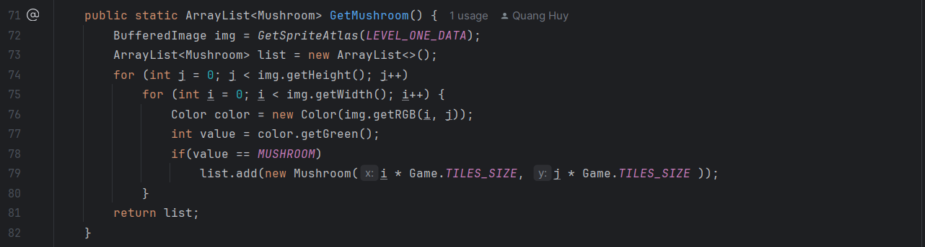

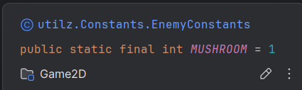

* **Purpose:** Identifies and retrieves the positions of all Mushroom objects in the level.
* **Parameters:** None.
* **Steps:**
  + Load the level data image using the GetSpriteAtlas method (line 72).

* + Iterate through each pixel in the image (line 74 - 81):
    - Pixel Color: Extract the green component of the pixel's RGB value.
    - Check if the green value equals the predefined MUSHROOM constant = 1 (line 77 - 78).
  + If a match is found:
    - Create a Mushroom object at the position derived from the pixel's coordinates (i * Game.TILES_SIZE, j * Game.TILES_SIZE) (line 79).
    - Add the Mushroom object to the list.

* + Return the list of Mushroom objects.

**3.3.3 GetJoker():**

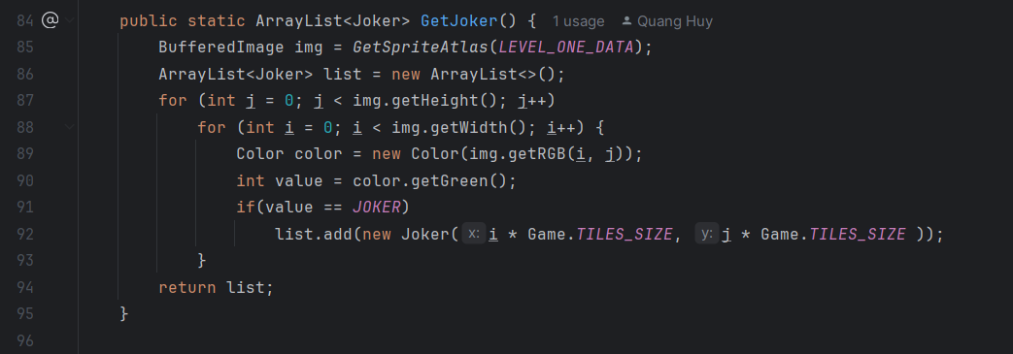

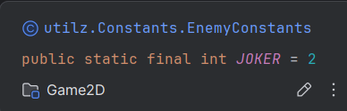

* **Purpose**: Locates and returns all Joker objects in the level.
* **Parameters**: None.
* **Steps**:
  + Load the level data image using the GetSpriteAtlas method (line 85).
  + Iterate through each pixel in the image (line 87 - 94):
    - **Pixel Color**: Extract the green component of the pixel's RGB value.
    - Check if the green value equals the predefined JOKER constant = 2(line 90 - 91).

* + If a match is found:

* + - Create a Joker object at the position calculated from the pixel's coordinates (i * Game.TILES_SIZE, j * Game.TILES_SIZE) (line 92).
    - Add the Joker object to the list.
  + Return the list of Joker objects.
    1. **How to load Enemies and draw Image of each type.**
* **Load Enemies’s Image**

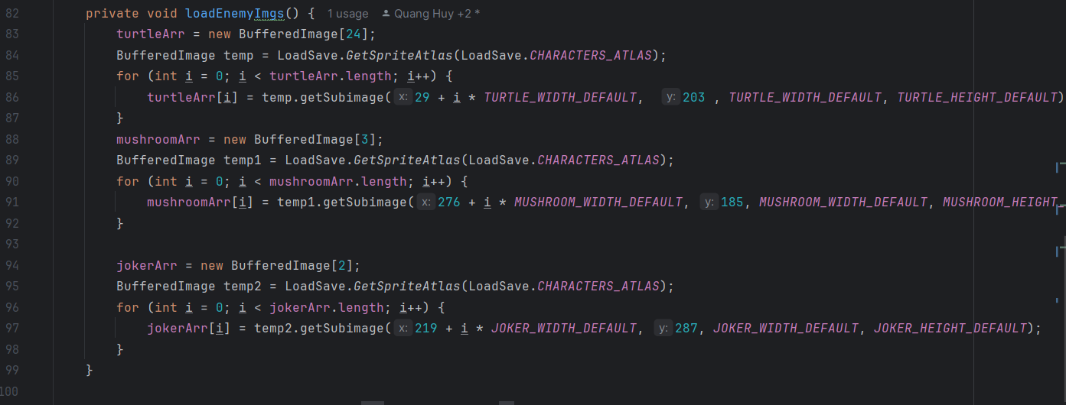

* + **Purpose:** Loads animation frames for each enemy type.
  + Uses the LoadSave.GetSpriteAtlas method to retrieve the sprite sheet (LoadSave.CHARACTERS_ATLAS) and extracts subimages for each frame of animation(line 84, 89, 95).
  + **How it works:**
    - Iterates through each frame for a given enemy type(line 85-87, 90-92, 96-98).
    - Uses the getSubimage method to extract a portion of the sprite sheet based on coordinates and dimensions.(line 86, 91, 97)
    - Stores each frame in the corresponding array (turtleArr, mushroomArr, jokerArr)(line 83, 88, 94).
* **Draw enemies' image**

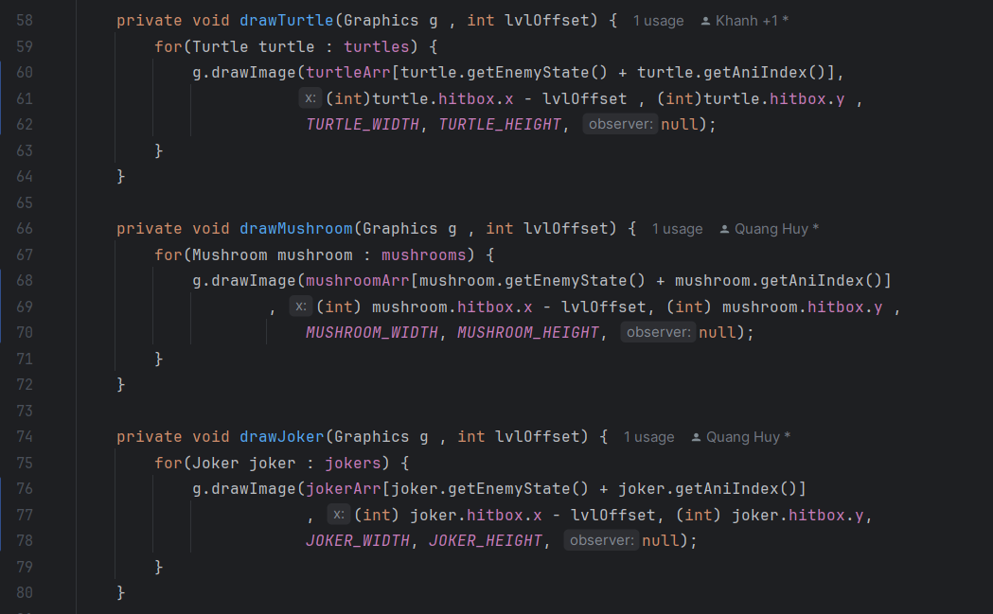

* **Purpose:**
* The method draws each enemies onto the game screen by:
* Choosing the correct sprite for the current animation frame and state.
* Positioning the sprite based on the Enemies's position (hitbox.x, hitbox.y).
* Scaling the sprite to the correct width and height.
* **To be more specific, for example, drawTurtle(Graphics g, int lvlOffset)**:
  + **Iterating Through All Turtles(line 59 - 64)**
    - This loop goes through every turtle in the turtles list, ensuring that all turtles are rendered on the screen.
  + **Selecting the Sprite (line 60 - 62):**

* + - **turtleArr**: An array of sprites for the Turtle enemy, where each element represents a specific animation frame or state.
    - **turtle.getEnemyState()**: Retrieves the current state of the Turtle (e.g., walking, idle, etc.). Different states correspond to different sets of sprites.
    - **turtle.getAniIndex()**: Retrieves the current animation frame index for the Turtle. This determines which frame of the animation to display for the current state.
    - The sum of turtle.getEnemyState() and turtle.getAniIndex() calculates the correct index in the turtleArr array to select the appropriate sprite.
  + **Positioning the Turtle**
    - **turtle.hitbox.x**: The x-coordinate of the Turtle's hitbox (essentially its position in the game world).
    - **lvlOffset**: The horizontal offset of the camera or level. Subtracting lvlOffset ensures that the Turtle is rendered in the correct position relative to the player's current view.
    - **turtle.hitbox.y**: The y-coordinate of the Turtle's hitbox, which directly determines the vertical position.
  + **Setting Dimensions:**

* + - TURTLE_WIDTH, TURTLE_HEIGHT
    - These constants define the width and height of the Turtle sprite when drawn on the screen. They ensure the sprite is scaled to the correct size.
    1. **Draw Method:**

This method is called every frame after update to render the enemies on the screen.

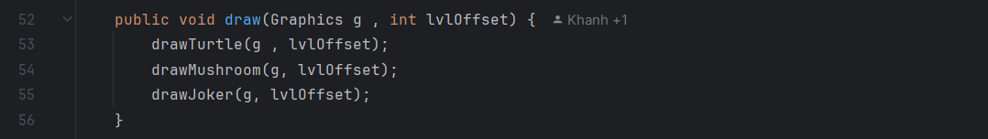

* Inside the draw Method:
  + Each type of enemy is rendered using the appropriate sprite (turtleArr, mushroomArr, jokerArr) based on its current animation frame and position.
    1. **Update Method:**

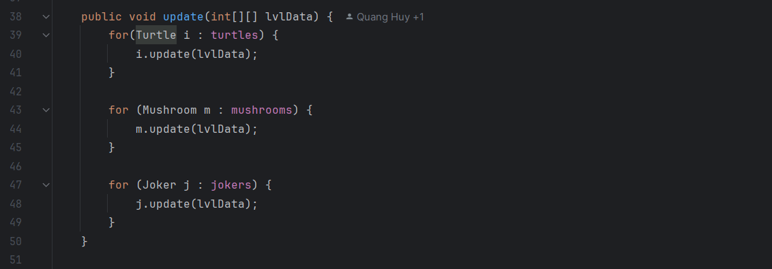

* **Purpose**: Updates the state of all enemies (e.g., position, animation, interactions).
* Iterates through each enemy list (turtles, mushrooms, jokers) and calls their update methods
  + 1. **addEnemies Method and Constructor:**
* **AddEnemies Method:**

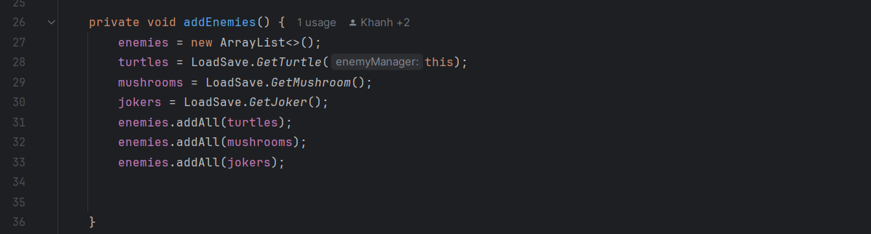

* + **Purpose**: Initializes the enemy lists and adds all enemy objects to the enemies list.
  + Calls the LoadSave methods to get the Turtle, Mushroom, and Joker objects from the level data.
* **Constructor**

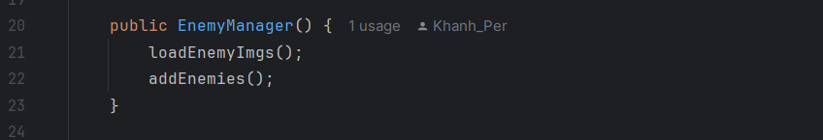

* **loadEnemyImgs()**: Loads the sprites (animation frames) for each enemy type from a sprite sheet.
* **addEnemies()**: Retrieves enemy objects and adds them to the appropriate lists.
  + 1. **Class variables:**

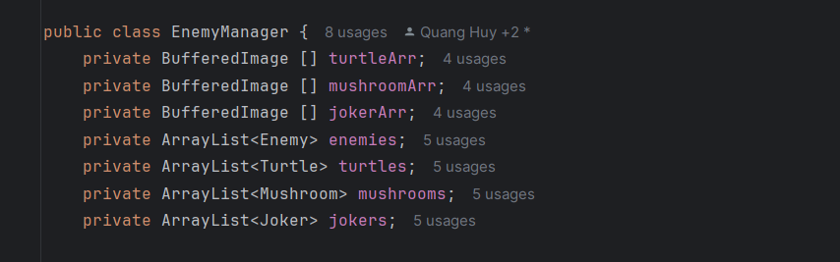

* **Image Arrays:**
* turtleArr, mushroomArr, jokerArr: Arrays of BufferedImage for storing animation frames for each enemy type(e.g. walking, dead, idle, etc.).
* **Enemies Lists**:
  + enemies: A unified list containing all enemies (Turtle, Mushroom, and Joker).
  + turtles, mushrooms, jokers: Separate lists for each enemy type
  1. **Enemies type and state:**

**In game play, our game gets three main types of enemies:**

**  
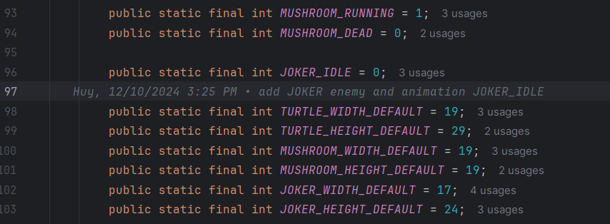**

**  
  
**

* As the loadEnemyImage() above, we will get the Datas, which were measured by software. From this, we will have coordinates and dimensions of each type of enemies. And these Datas will put into LoadEnemyImage() to do it purpose.

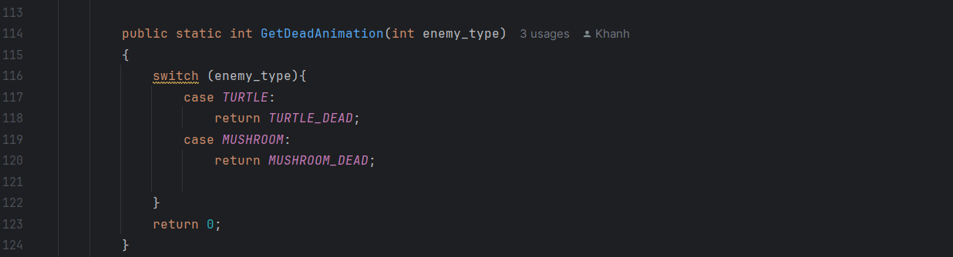

* This method returns the dead animation state for a given **enemy_type**:
  + If **enemy_type** is TURTLE, it returns **TURTLE_DEAD**.
  + If **enemy_type** is MUSHROOM, it returns **MUSHROOM_DEAD**.
  + For other enemy types (e.g., JOKER), it returns 0 by default.

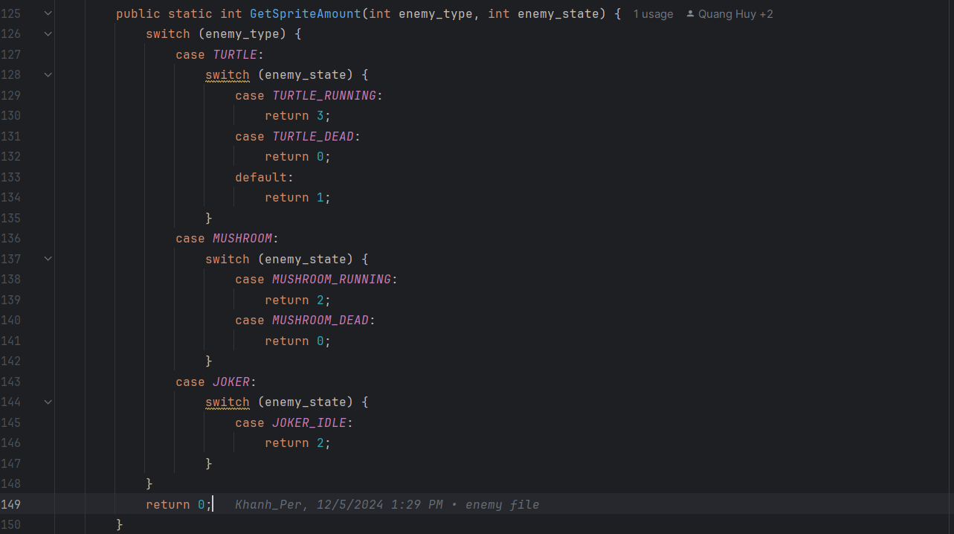

* **Based on the enemy_type:**
  + If it's a TURTLE, check the enemy_state:
    - TURTLE_RUNNING: There are **3 animation frames**.
    - TURTLE_DEAD: There are **0 animation frames**.
    - Default case: **1 animation frame**.
  + If it's a MUSHROOM, check the enemy_state:
    - MUSHROOM_RUNNING: There are **2 animation frames**.
    - MUSHROOM_DEAD: There are **0 animation frames**.
  + If it's a JOKER, check the enemy_state:
    - JOKER_IDLE: There are **2 animation frames**.

* + If no match is found, return 0 by default.

### **4.Why enemy is the abstract class?**

Enemy class is an abstract class, because it represents a base template for all enemy types in the game. It contains common properties and methods shared by all enemies, including movement, etc.

1. **Class Variables and Constructor:**

* **Class Variables:**

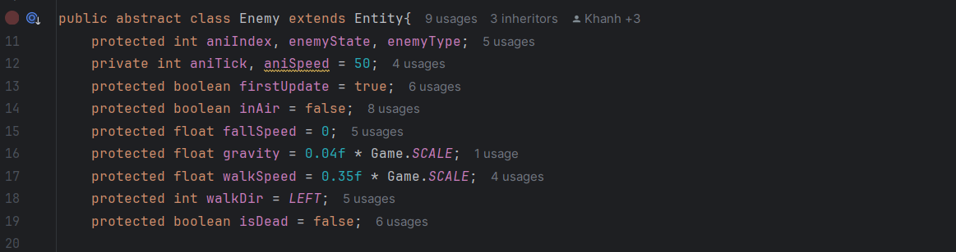

* **aniIndex:** Keeps track of the current animation frame.
* **enemyState:** Indicates the current state of the enemy (e.g., running, idle, or dead). Values are defined in EnemyConstants.
* **enemyType:** Represents the type of enemy (e.g., Turtle, Mushroom, Joker). Values are also defined in EnemyConstants.
* **Constructor:**

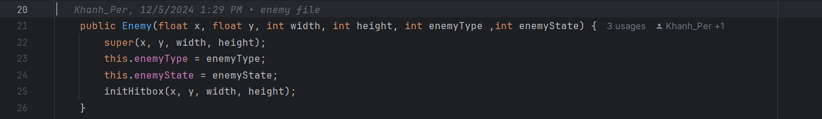

* **Parameters:**
  + x, y: Initial position of the enemy.
  + width, height: Dimensions of the enemy.
  + enemyType: The type of the enemy.
  + enemyState: Initial state of the enemy.
  + Calls the parent Entity constructor and initializes the enemy's hitbox.

1. **Methods of Enemy:**

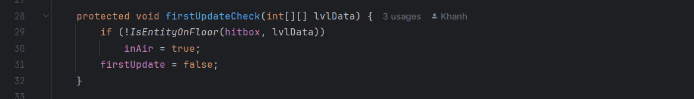

**firstUpdateCheck(int[][] lvlData):**

* Checks if the enemy is on the floor during its first update.
* Sets inAir to true if the enemy is not on the ground.

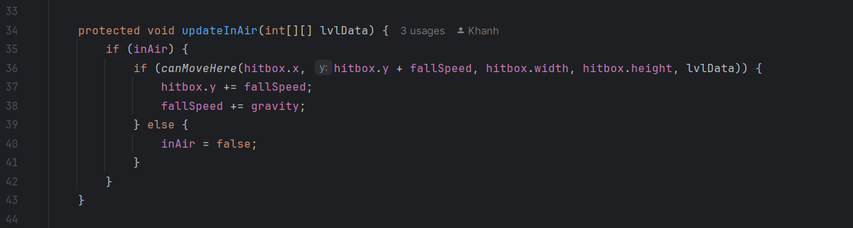

**updateInAir(int[][] lvlData):**

* **Handles enemy movement while airborne(line 35 - 39):**
  + **If the enemy can move downward without hitting a surface, it falls (hitbox.y is incremented by fallSpeed).**
    - **fallSpeed increases due to gravity, simulating acceleration.**
    - **If the enemy cannot move downward, it lands (inAir = false) (line 40).**

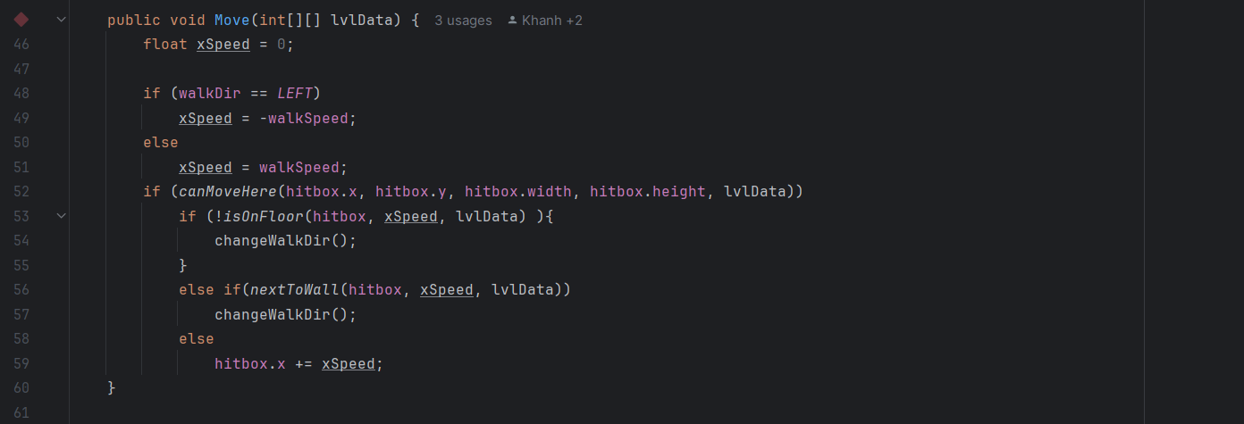

**Move(int[][] lvlData):**

* **Handles horizontal movement:**
  + Moves left (xSpeed = -walkSpeed) or right (xSpeed = walkSpeed) based on walkDir(line 46 - 51).
  + If the enemy cannot move due to hitting a wall or losing ground, it changes direction by calling changeWalkDir()(line 53 - 59).

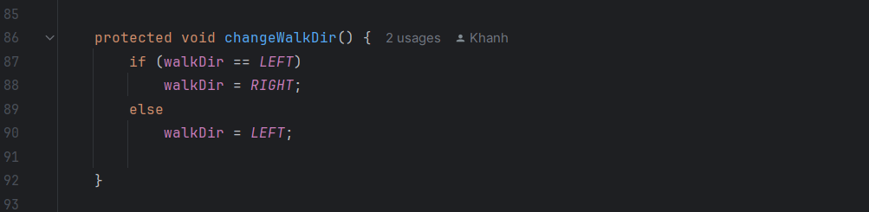

**changeWalkDir():**

* Reverses the walking direction.

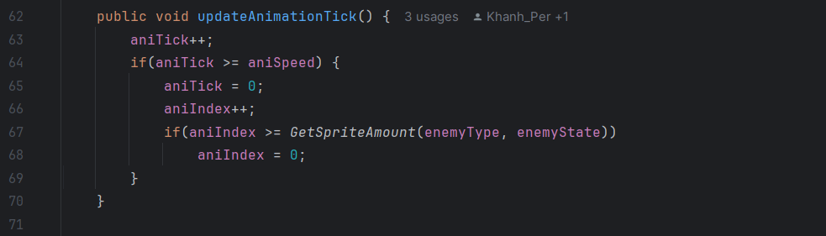

**updateAnimationTick():**

* Advances the animation frame (aniIndex) periodically based on aniSpeed.
* Resets aniIndex to 0 once all frames for the current state are played(line 64 - 66).
* Uses GetSpriteAmount() from Constants to determine the total frames for the enemy type and state (line 67 - 68).

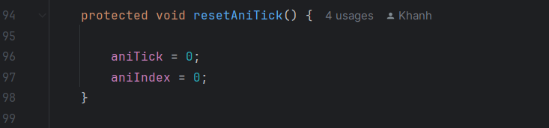

**resetAniTick():**

* Resets the animation tick and index to ensure the animation starts from the first frame.

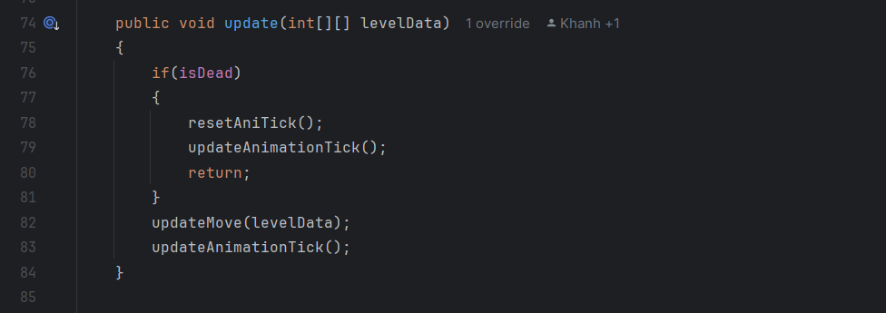

**update(int[][] levelData):**

* Updates the enemy:
  + If the enemy is dead, reset the animation tick and update the animation (for death animations) (line 76 - 79).
  + Otherwise, update the enemy's movement and animation(line 82 - 83).



**updateMove(int[][] lvlData):**

* Abstract method for enemy-specific movement logic. Each enemy type (e.g., Turtle, Mushroom, Joker) must implement this method.

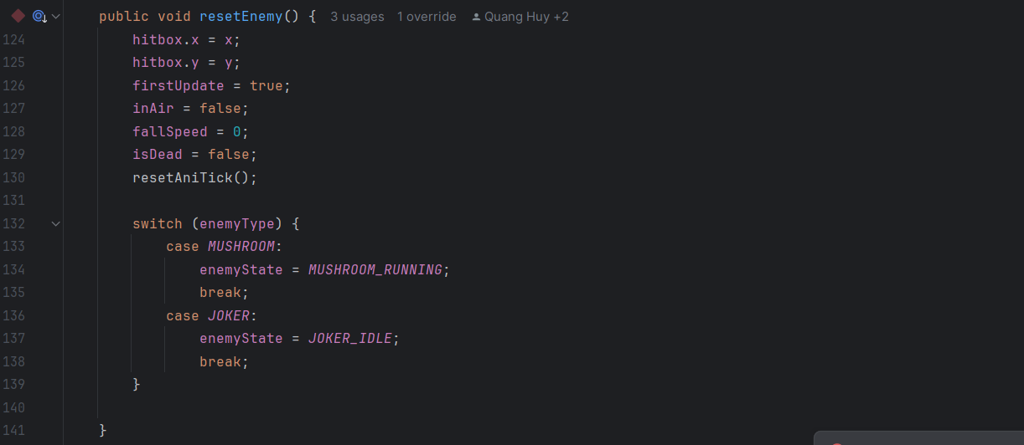

**resetEnemy():**

* Resets the enemy's position, state, and properties to their initial values.

### **5. Turtle, Mushroom, Joker class:**

1. **Class Turtle:**
   1. **Variables and constructor in Turtle:**



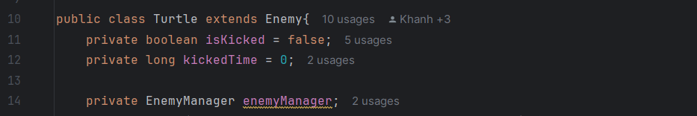

* **isKicked:** Tracks whether the Turtle has been kicked (e.g., by the player).
* **kickedTime:** Records the time when the Turtle was kicked, used to determine a grace period after being kicked.
* **enemyManager:** A reference to the EnemyManager class that manages all enemies.

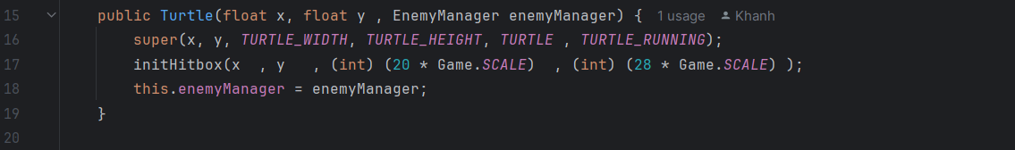

* **Parameters:**
  + x, y: Initial position of the Turtle.
  + nemyManager: Reference to the EnemyManager.
  + Initializes the hitbox with specific dimensions,

20 is the TURTLE_WIDTH_DEFAULT,

28 is TURTLE_HEIGHT_DEFAULT (line 17).

* 1. **Movement and behavior:**

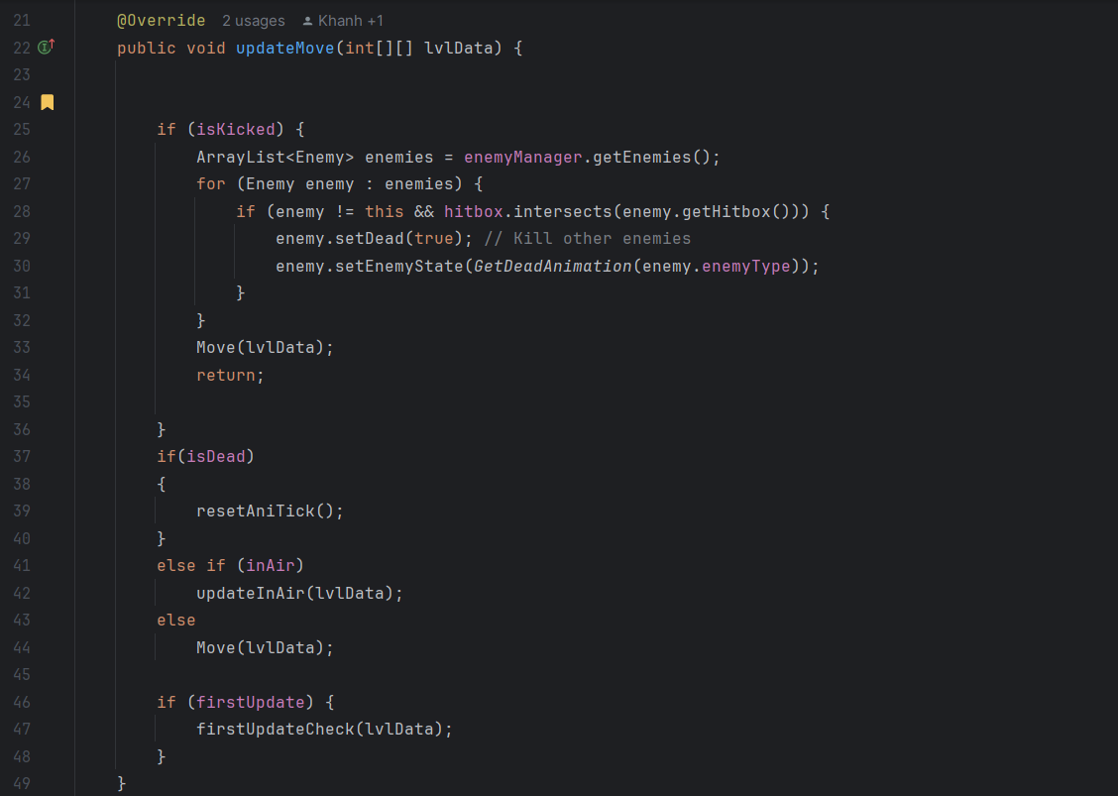

* **When isKicked is true(line 25 - 32):**
  + Checks for collisions with other enemies in the game.
    - If a collision occurs, the other enemy is marked as dead (setDead(true)) and its state is updated to the "dead animation." (line 28 - 30).
  + The Turtle moves using the Move() method(line 33).
* **When isDead is true(line 37 - 40):**
  + Resets the animation tick to stop any ongoing movement or animation.
* **When inAir is true(line 41 - 42):**
  + Handles falling due to gravity using updateInAir().
* **Otherwise:**

* + Executes normal movement logic(line 44).

* If this is the first update, checks if the Turtle is airborne using firstUpdateCheck()(line 46 - 48).

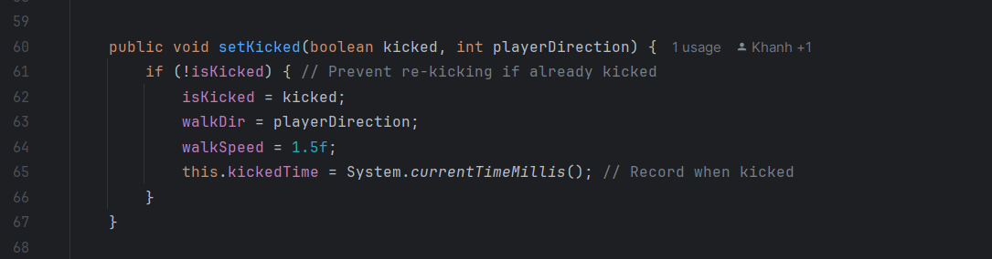

* **Sets the Turtle's state to "kicked" and adjusts its behavior:**

* + Sets isKicked to true (if not already kicked).
  + Updates the Turtle's walking direction (walkDir) to match the player's direction.
  + Increases the walking speed to 1.5f (faster than normal).
  + Records the time the Turtle was kicked (kickedTime) for tracking the grace period.

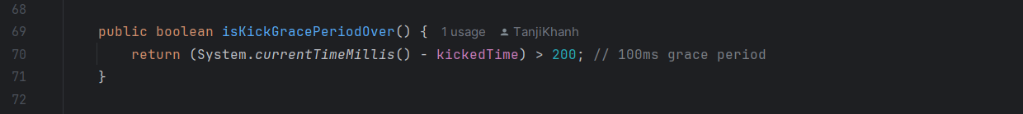

* Determines if a brief grace period (200 milliseconds) after being kicked has passed.
* Prevents instant re-kicks or actions that require time to settle.

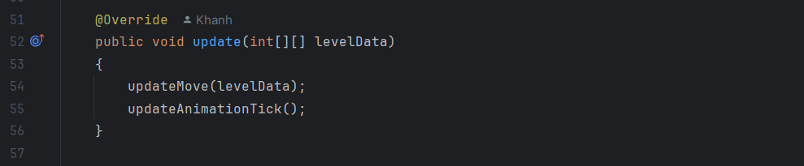

* Combines the movement logic (updateMove) with animation updates (updateAnimationTick) for the Turtle(line 54 - 55).
* Ensures animations remain synchronized with the Turtle's state and actions.

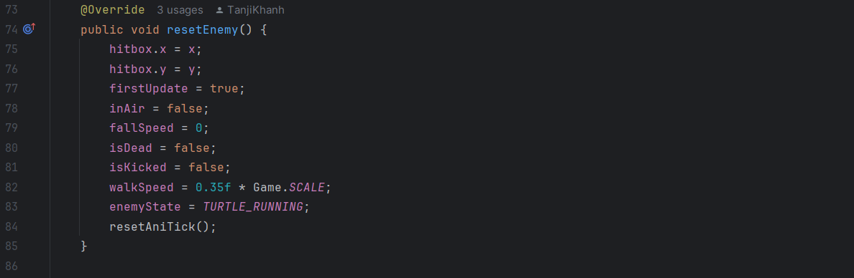

* **Resets the Turtle's properties to their initial values:**
  + Resets position, falling state, speed, and animation(line 75 - 81).
  + Sets isKicked to false and restores normal walking speed(line 82).
  + Updates the Turtle's state to "running."(line 83)

1. **Class Mushroom:**
   1. **Constructor in Turtle:**



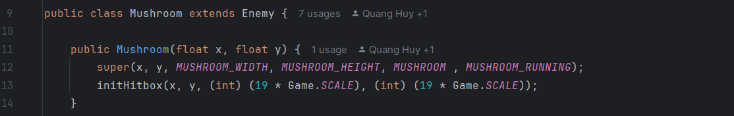

* **Parameters:** The constructor takes x and y as initial position coordinates.
* **Super Constructor:** Calls the Enemy constructor with:
  + x, y: Position coordinates.
  + MUSHROOM_WIDTH and MUSHROOM_HEIGHT: Dimensions of the mushroom.
  + MUSHROOM: Identifier for the mushroom type (enemyType).
  + MUSHROOM_RUNNING: The mushroom's running animation (enemyState).
* **Hitbox Initialization:** 
  + Defines the mushroom's hitbox with dimensions proportional to the game's scale, 19 is the MUSHROOM_WIDTH_DEFAULT and 19 is MUSHROOM_HEIGHT_DEFAULT (line 13).
  1. **Movement of mushroom:**

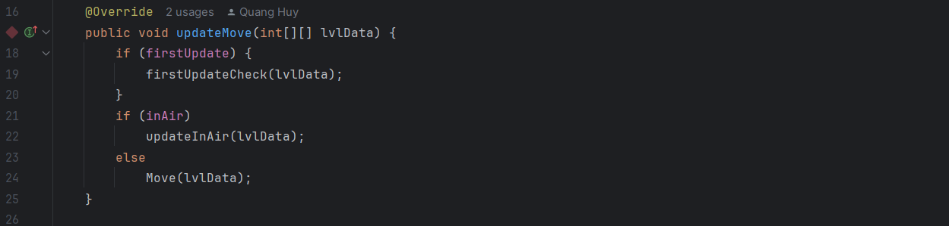

* **firstUpdateCheck: Runs initial setup (e.g., setting starting states).**
* **Movement (line 21 -24):**
  + If the mushroom is in the air (inAir), the updateInAir method is called, likely handling gravity or falling logic.
  + Otherwise, the Move method handles normal movement, such as walking to the player.
  1. **Class Joker:**
  2. **Constructor in Joker:**



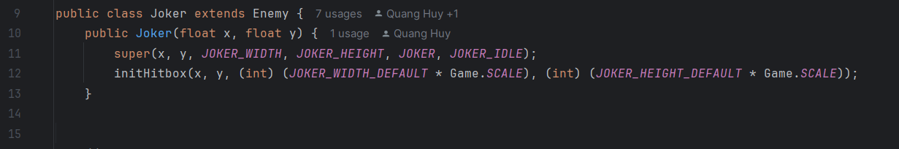

* **Parameters:**
  + x and y: Initial position coordinates.
* **super Constructor:**
  + JOKER_WIDTH and JOKER_HEIGHT: Dimensions specific to the Joker.
  + JOKER: Identifier for this Joker type (enemyType).
  + JOKER_IDLE: Default animation state for the Joker, which seems to be (enemyState).
* **Hitbox Initialization:**
  + The hitbox is scaled based on Game.SCALE to ensure proper collision detection

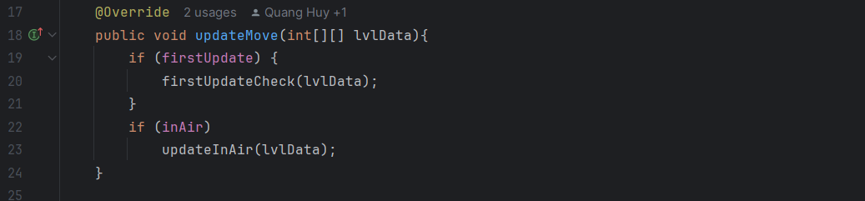

* **firstUpdateCheck:** Initializes any required state during the Joker's first update.

* **inAir:** If the Joker is airborne, it updates its movement (e.g., applying gravity).

### **6.  Level:**

1. **Game constant:**

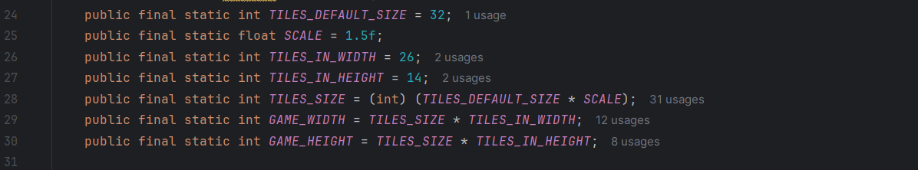

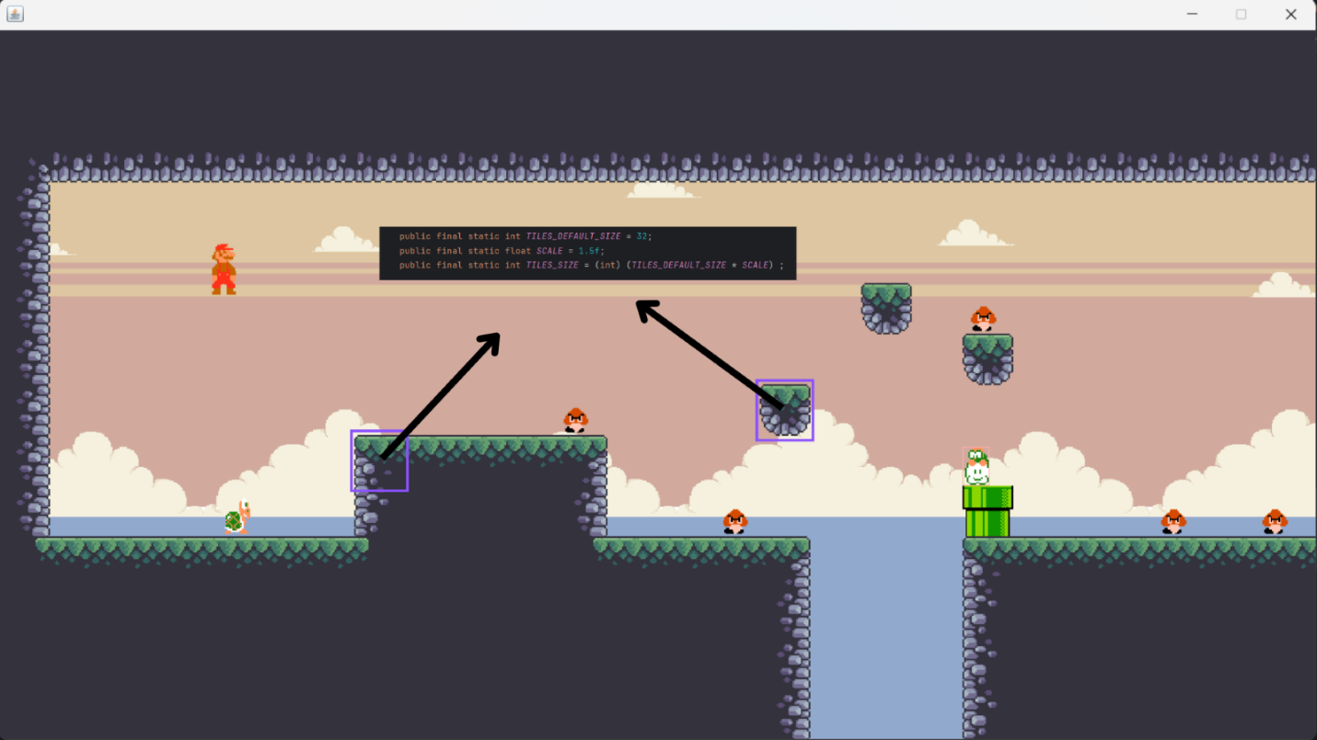

* Our game map is divided into equal tiles, each with a default size of 32px x 32px. The game screen consists of 26 tiles in width and 14 tiles in height, ensuring a balanced and structured layout. To enhance user experience, we implemented a scale factor of 1.5f, allowing tiles to scale up to 48px x 48px, which also supports zooming in and out.

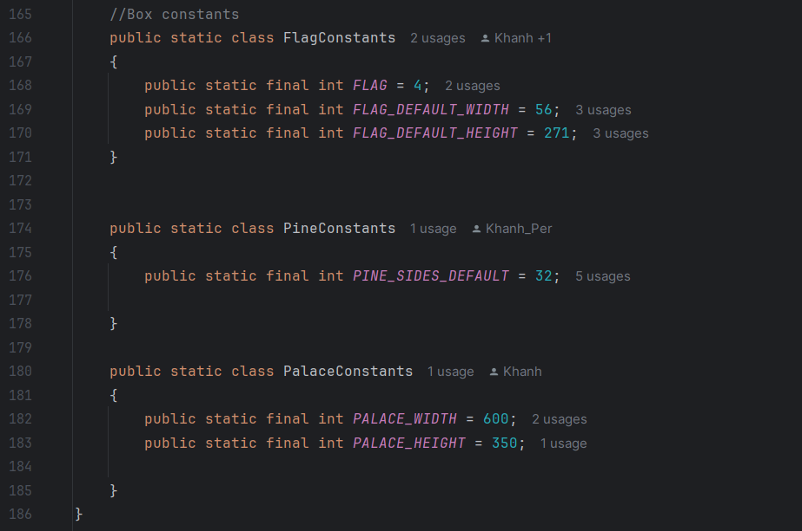

1. **Load level data:**

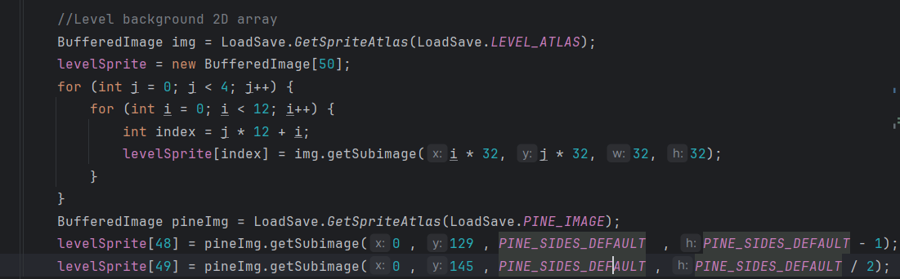

* **Line 61:** Retrieve a larger image (sprite atlas) that contains smaller sprites arranged in a grid**.**
* **Line 62 - 68:** The nested loop extracts smaller sprites (32x32 pixels each) from the sprite atlas and stores them in the levelSprite array.
* **Line 69 – 71:** The code loads another sprite atlas (PINE_IMAGE) and extracts two pine additional sprites to fill specific slots in the levelSprite array.

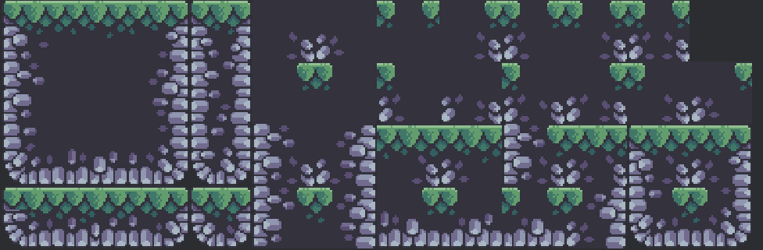

**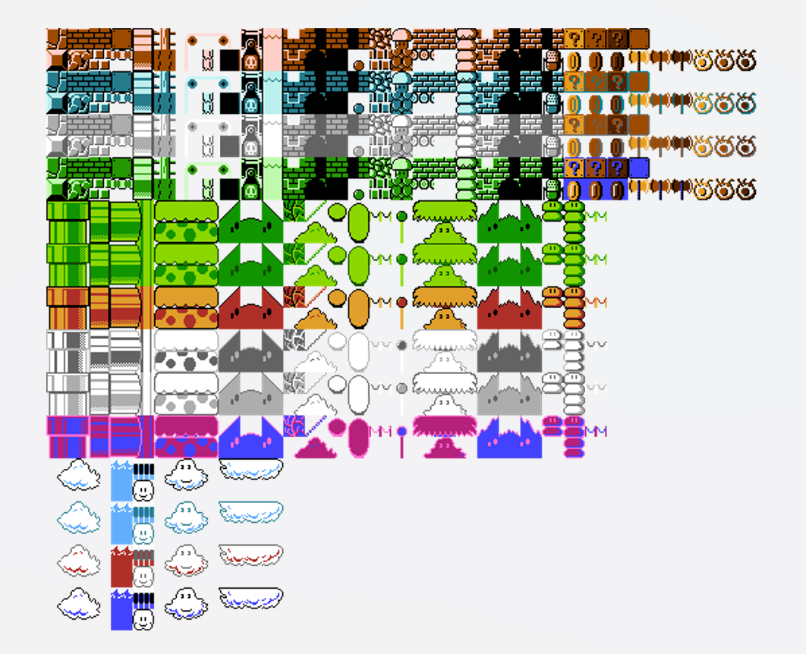  
Import Background Image.**

1. **Draw levelData:**

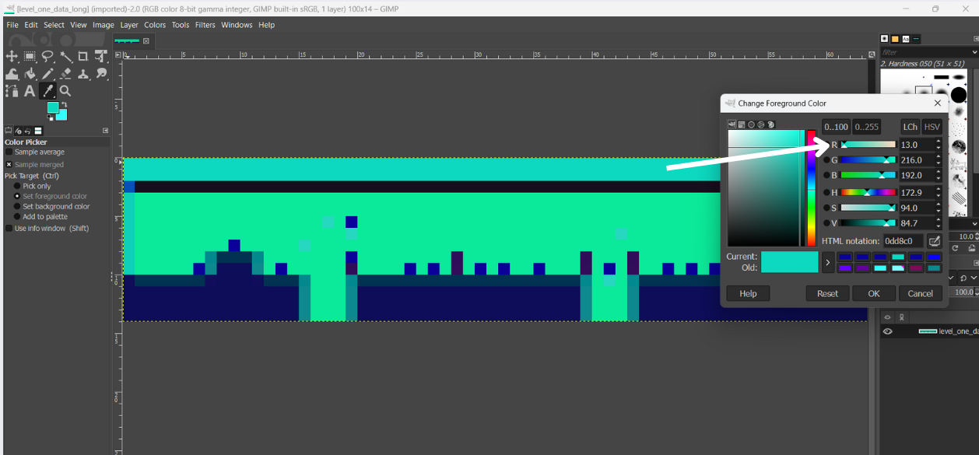

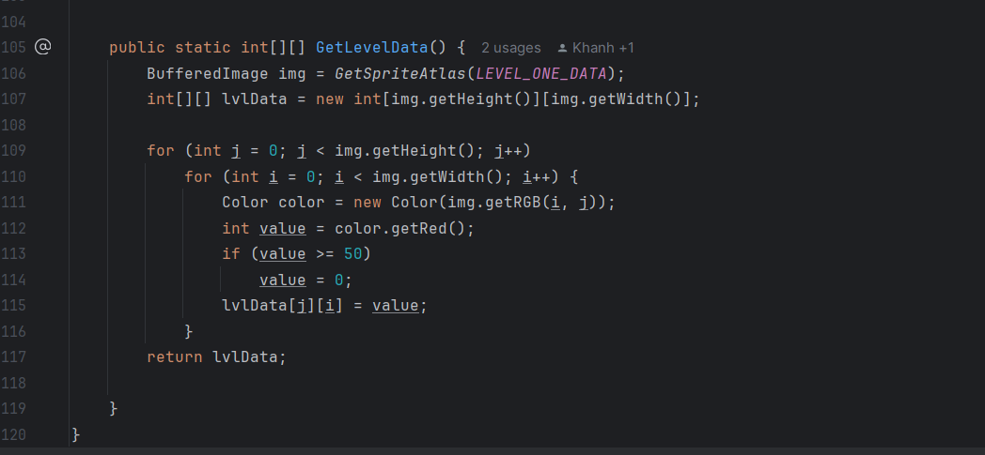

* For each block, we assign the red color value of the corresponding pixel to the specific index in the levelSprite array where we want to draw the block.

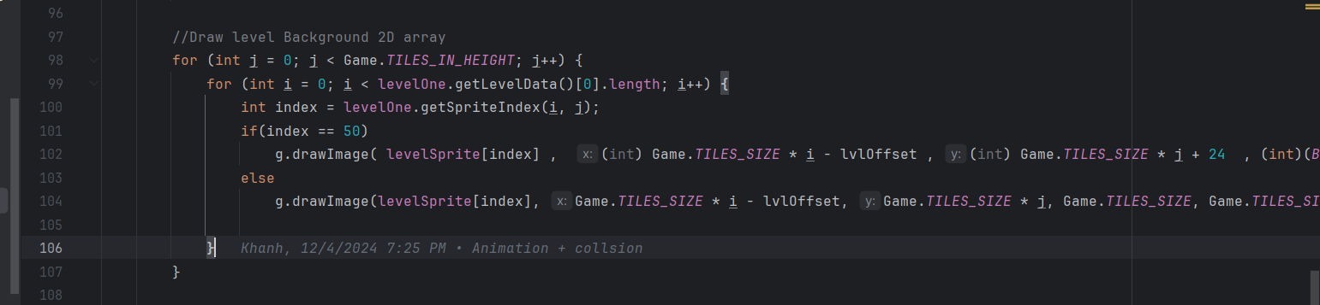

### **7.Collision:**

* 1. **HelpMethods:**
  2. **isSolid:**

This method is used to check if a coordinate (x, y) on the game map is on a solid tile**.**

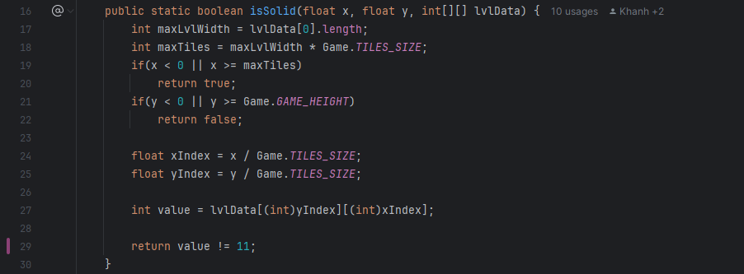

* **Firstly, we calculate map dimensions by using lvlData (2D array) to represent the map where each element corresponds to a tile type (line 17, 18):**
  + maxLvlWidth: The number of tiles in a row of the map.
  + maxTiles: The total width of the map in pixels (number of tiles * tile size).
* **Secondly, we check the x and y coordinates to see if x and y is out of bounds horizontally and vertically, correspondently (from line 19 to 22):**
  + if x is less than zero or greater than or equal to the total width (maxTiles), the coordinate is    outside the horizontal map boundary. We return “true”, this means that positions outside the map are treated as “solid” to prevent movement beyond boundaries.
  + if x is less than zero or greater than or equal to Game.GAME_HEIGHT (the game’s vertical height), the coordinate is out of bounds vertically. We return “false”, this means that positions outside the vertical boundary are treated as “non-solid” (not blocking).
* **Thirdly, we calculate tile indices (line 24, 25):**
* Game.TILE_SIZE: the size of one tile in pixels.
* We divide x and y by TILE_SIZE to calculate the index of the corresponding tile in the “lvlData” array.
* **Finally, we check the tile value (from line 27 to 29):**
* lvlData[(int) yIndex] [(int) xIndex]: retrieves the value of the tile at (xIndex, yIndex).
* If the tile value is not 11, the method returns true (solid).
* If the tile value is 11, the method returns true (non-solid).
* 11 is the value of non-solid tile in level image (in “res” package).
  1. **canMoveHere:**

This method checks whether the given hitbox (representing an object or entity in the game world) can be placed or moved to a specific position (x, y)without colliding with solid tiles.

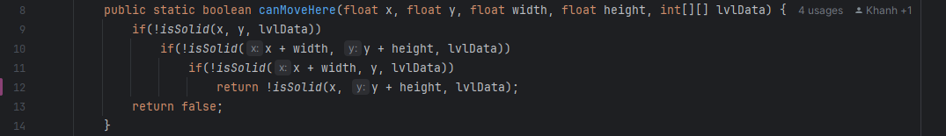

* **Parameters (line 8):**

* + x and y: The top-left corner coordinates of the hitbox.
  + width and height: The dimensions of the hitbox (object size).
  + lvlData: a 2D array of tiles.
* **Check solid tile (from line 9 to 14):**
  + *!isSolid(x, y, lvlData):* Checks if the top-left corner is not solid.
  + *!isSolid(x + width, y + height, lvlData):* Checks if the bottom-right corner is not solid.
  + *!isSolid(x + width, y, lvlData):* Checks if the top-right corner is not solid.
  + *!isSolid(x, y + height, lvlData):* Checks if the bottom-left corner is not solid.
  + *“return false”:* If any of the corners are solid, the method immediately returns “false”, meaning the object cannot move to the specified position.
  1. **GetEntityXPosNextToWall:**

This method calculates the next valid X position for an entity when it is moving horizontally toward a wall.

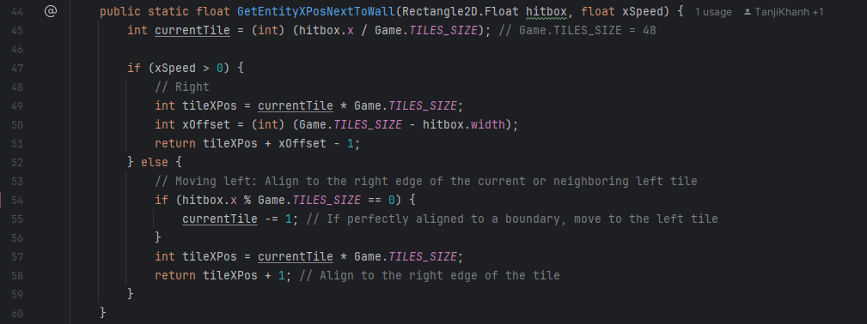

* **Parameters (line 44):**
  + *Rectangle2D.Float hitbox:* The bounding box of the entity.
  + *float xSpeed:* The horizontal movement speed of the entity (positive for moving right and negative for moving left).
* **Current tile calculation (line 45): This shows the current tile index (horizontal position) based on the entity’s X-coordinate and the tile size (48).**
* **Moving right (from line 47 to 51): Align the entity to the left edge of the next tile when moving right.**
  + *tileXPos = currentTile * Game.TILE_SIZE:* calculates the left edge of the current tile.
  + *xOffset = Game.TILE_SIZE – hitbox.width:* calculates the horizontal offset needed for the entity to align its right edge with the wall.
  + Subtracing 1 ensures tiny buffer, so the entity does not clip into the wall.
* **Moving left (from line 52 to 56): Align the entity to the right edge of the current or left neighboring tile when moving left.**
  + if *hitbox.x % Game.TILE_SIZE = 0*: The entity is aligned with a tile boundary, so it checks the previous tile.
  + *tileXPos = currentTile * Game.TILE_SIZE:* calculates the left edge of the current tile.
  + Adding 1 aligns the entity’s left edge away from the wall to avoid clipping.
  1. **GetEntityYPosUnderRootOrAboveFloor:**

This method determines the exact Y-coordinate where an entity should stop when it collides with:

* A floor while falling.
* A roof while jumping.

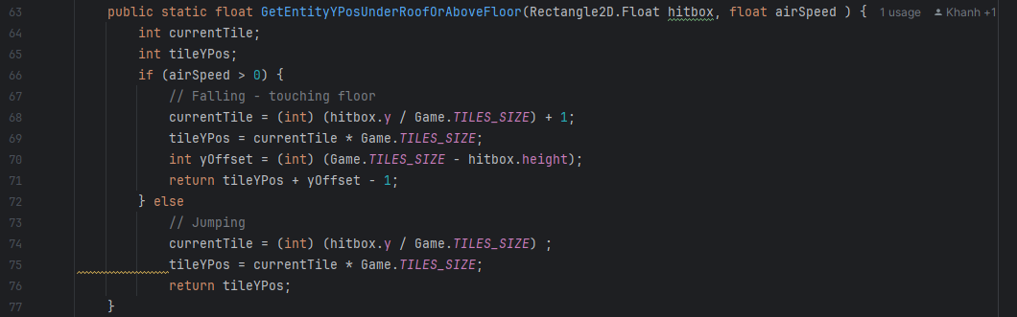

* **Parameters (line 63):**

* + *Rectangle2D.Float hitbox:* The bounding box of the entity.
  + *float airSpeed*: The vertical movement speed of the entity (Positive for falling, negative for jumping).
* **Falling (airSpeed > 0) (from line 65 to 71):**
  + currentTile: The tile immediately below the entity *(hitbox.y / Game.TILES_SIZE + 1).*
  + *tileYPos:* The Y-coordinate of the top edge of this tile.
  + *yOffset:* Adjusts the entity's bottom edge *(Game.TILES_SIZE - hitbox.height*) so it aligns perfectly with the floor.
  + Subtracting 1 creates a small buffer to ensure the entity doesn’t visually overlap with the floor.
* **Jumping (airSpeed <0) (from line 72 to line 76):** 
  + The method simply returns this value to position the entity right below the roof**.**
  1. **isEntityOnFloor and isOnFloor:**
* IsEntityOnFloor: This method checks if an entity is standing on the floor by verifying the solidity of the tiles directly below its bottom-left and bottom-right corners.
* IsOnFloor: This method determines if the entity is on the floor while accounting for its horizontal speed (xSpeed). It checks the solidity of the tiles below the bottom-left or bottom-right corner based on the direction of movement.

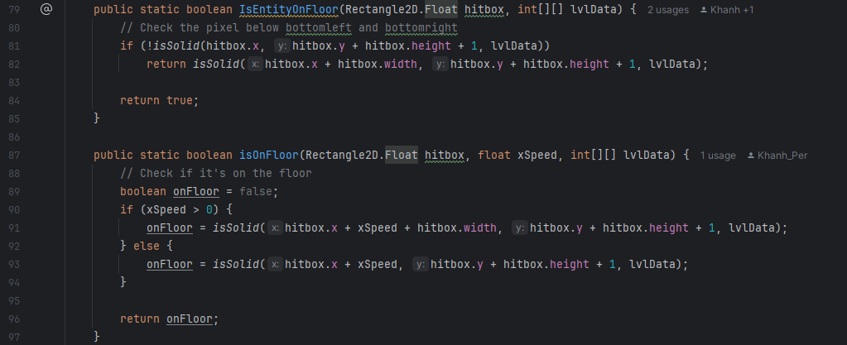

* 1. **nextToWall:**

This method checks if an entity's hitbox is next to a wall based on its horizontal speed (xSpeed). This is useful for preventing the entity from moving through walls and ensuring proper collision behavior.

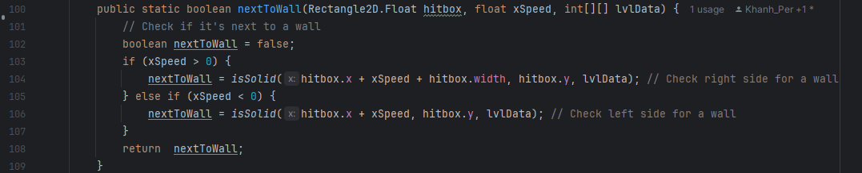

* **xSpeed > 0 (moving right) (line 103, 104):** Checks the right edge of the hitbox.
* **XSpeed < o (moving left) (line 105, 106):** Checks the left edge of the hitbox.
* ***“Return true”:*** if the entity is next to a wall on the side it is moving toward.
  1. **playerCollisionAboveEnemies:**

This method determines whether the player's hitbox collides with an enemy's hitbox from above.

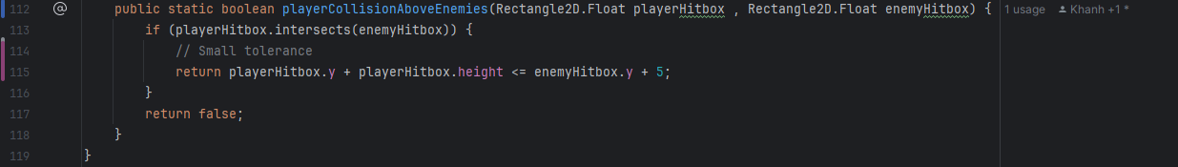

* **Parameters:**
  + *Rectangle2D.Float playerHitbox:* Represents the bounding box of the player character.
  + *Rectangle2D.Float playerHitbox:* Represents the bounding box of the enemy character.
* **Intersections check:**
  + *“if (playerHitbox.intersects(enemyHitbox))”:* The method first checks if the player's hitbox and the enemy's hitbox intersect.
* **Condition:**
  + ***“return playerHitbox.y + playerHitbox.height <= enemyHitbox.y + 5;”:***
    - If the hitboxes intersect, the method checks if the player's bottom edge *(playerHitbox.y + playerHitbox.height*) is just above the enemy's top edge (enemyHitbox.y).
    - The *+5* adds a small tolerance to account for slight overlaps or imperfections in hitbox alignment.
* ***“return false”:*** If the hitboxes do not intersect, or the player is not above the enemy, themethod returns false.

1. **Update player position and gravity:**

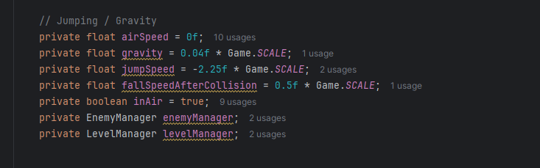

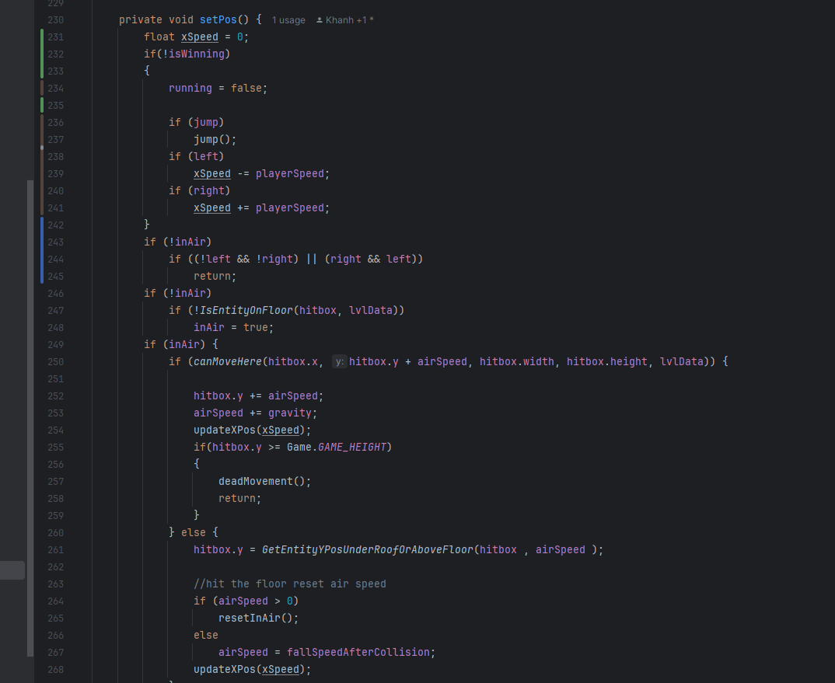

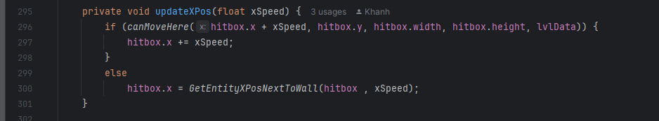

1. **Horizontal Movement Handling:**

* **xSpeed is adjusted based on the player's input:**
  + If the player presses the A (left) key, xSpeed decreases by playerSpeed.
  + If the player presses the D (right) key, xSpeed increases by playerSpeed.
  + If the player is idle or moving in opposite directions simultaneously, no horizontal movement is applied.

1. **Airborne State Management:**

If the player is not already airborne (inAir = false), the function checks whether the player is on the ground using IsEntityOnFloor. If not, the player enters the airborne state (*inAir = true).*

1. **Vertical Movement Handling (Airborne Logic):**

* **When airborne, the function:**
  + Checks if the player can move to the next vertical position *(canMoveHere).*
  + If movement is possible:
    - Updates the *hitbox.y* position based on airSpeed.
    - Increments *airSpeed* by gravity to simulate acceleration.
    - Calls *updateXPos* to handle horizontal movement.
    - If the player falls out of bounds, *deadMovement* is triggered to handle death logic.
  + If movement is blocked (e.g., hitting a floor or ceiling):
    - Aligns the player to the appropriate position using *GetEntityYPosUnderRoofOrAboveFloor*.
    - Resets *airSpeed* appropriately for the collision direction.
    - Calls *updateXPos*.

1. **Horizontal Movement on Ground:**

When not airborne, horizontal movement (*updateXPos*) is applied directly if the player is pressing left or right**.**

1. **Sound:**

#### **9.1 Sound package:**

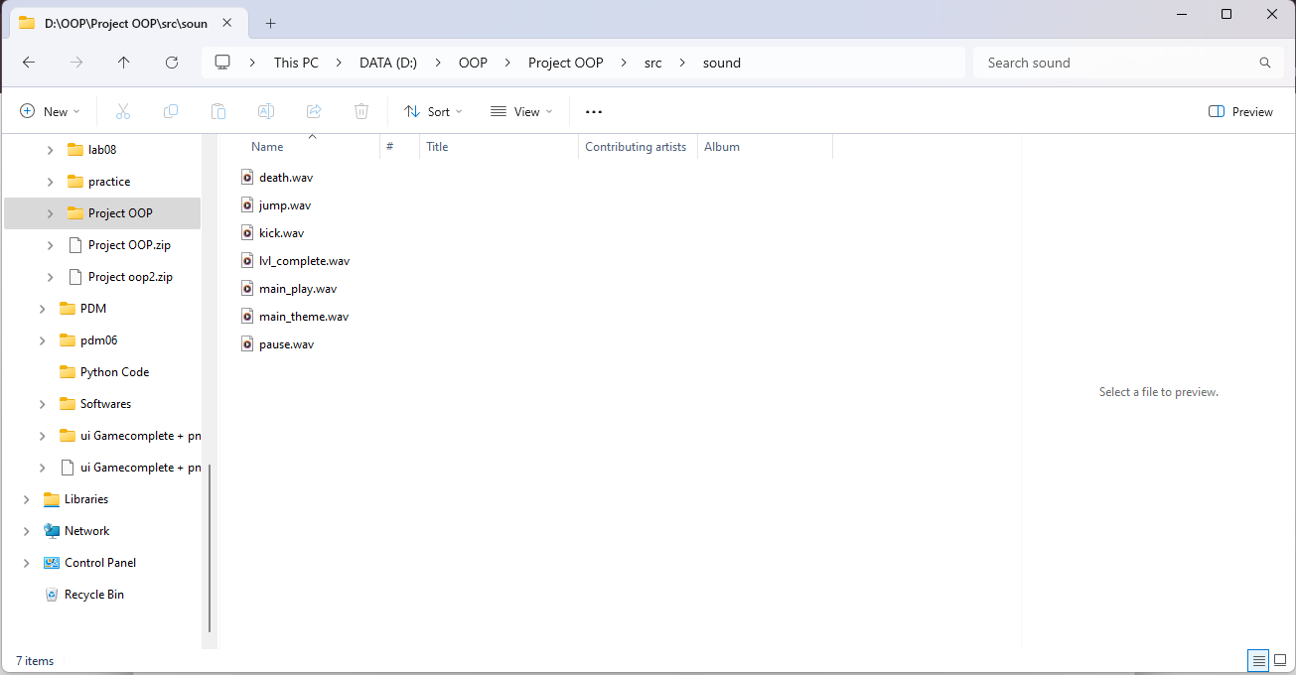

This is a sound package that stores the background music and sound effects of the characters and games. And these sounds are formatted as wav.

* 1. **audio package:**

**audioPlayer:**

This class is designed to handle both background music and sound effects in a game. It uses the javax.sound.sampled API for managing audio clips, offering features such as volume control, mute toggling, and looping playback for background music. Here are the key strengths and some suggestions for improvement.

* **Attributes (from line 16 to line 28):**

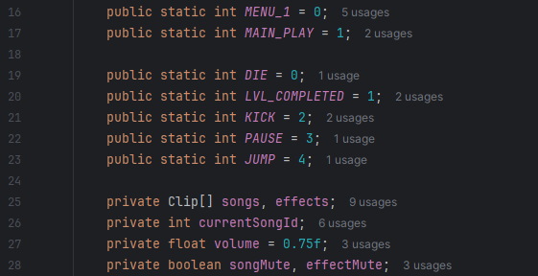

* + **We divide all attributes into 3 parts:**
    - The first part is attributes of background music.
    - The second part is attributes of effect sound.
    - The final part is used to store the remaining attributes.
* **Constructor (from line 30 to 34):**



This constructor is based on the purpose of each method within it.

* **loadSong and loadEffect (from line 36 to 50):**

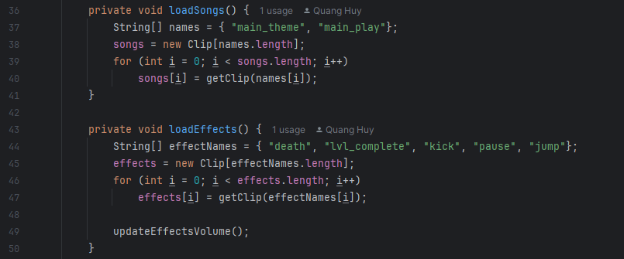

* **“*loadSong”* method:** This method is to load the background music clips into the songs array.

* + *“String[] names = { "main_theme", "main_play" };”:* An array of strings containing the names of the music tracks to be loaded. In this case, the background music files are named "main_theme" and "main_play".
  + *“songs = new Clip[names.length];”:* Initializes the songs array with the same length as the names array.
  + *“songs[i] = getClip(names[i]);”:* For each name in the names array, the getClip() method is called to retrieve the Clip object (which represents the audio file), and it's stored in the songs array at the corresponding index.
* ***“loadEffect”* method:** This method is to load the sound effect clips into the effects array.
  + “*String[] effectNames = { "death", "lvl_complete", "kick", "pause", "jump" };”:* An array of strings containing the names of sound effects to be loaded ("death", "lvl_complete", "kick", "pause", and "jump").
  + *“effects = new Clip[effectNames.length];”:* Initializes the effects array with the same length as the effectNames array to hold the sound effect clips.
  + *“effects[i] = getClip(effectNames[i]);”:* Like the loadSongs() method, it calls the getClip() method to retrieve the sound effect (Clip object) for each name and stores it in the effects array.
  + *“updateEffectsVolume();”:* After all sound effects are loaded, this method adjusts their volume based on game settings or preferences, ensuring consistent audio behavior for all effects.
* **GetClip (from line 52 to 63):**

This method is designed to retrieve an audio clip based on the provided name.

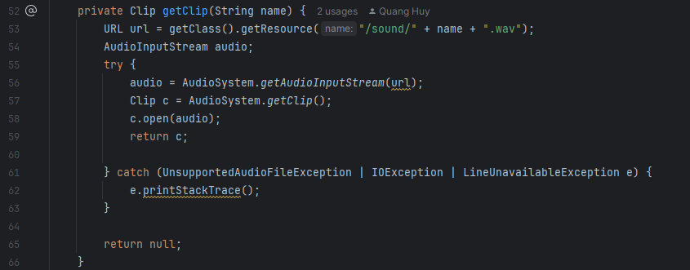

* + *“getClass().getResource("/sound/" + name + ".wav")”:* retrieves the resource (audio file) by constructing a URL*.* It looks for a .wav file located in the /sound/ folder in the resources of the project. The name parameter is dynamically used to build the path to the specific sound file.
  + *“AudioSystem.getAudioInputStream(url)”:* reads the audio file (using the URL) and converts it into an AudioInputStream, which is a representation of the audio data that can be processed by the Java Sound API.
  + *“Clip c = AudioSystem.getClip();”:* This creates a new Clip object, which is a special type of Line that can hold and play an audio stream. Clips are used for short-duration sound effects or looping audio.
  + *“c.open(audio);”:* opens the Clip and loads the audio data from the AudioInputStream (the audio file) into the clip, making it ready for playback.
  + “return c;”: The method returns the fully loaded Clip object so it can be used to play the audio.
* **Exceptions:**
  + *“UnsupportedAudioFileException”:* This exception is thrown if the audio file is not supported (e.g., the file format is incorrect).
  + *“IOException”:* This exception occurs if there's an error reading the audio file.
  + *“LineUnavailableException”:* This exception is thrown if a line (such as the Clip) cannot be opened or accessed for some reason (e.g., no available system resources).
  + *“e.printStackTrace();”:* If an exception occurs, the stack trace is printed to the console for debugging purposes.
  + *“return null”:* If any exception occurs during the audio loading process, the method returns null to indicate that the clip could not be loaded successfully.
* **updateSongVolume and updateEffectVolume (from line 122 to line 137):**

These two methods manage the volume adjustment for songs and **s**ound effects respectively.

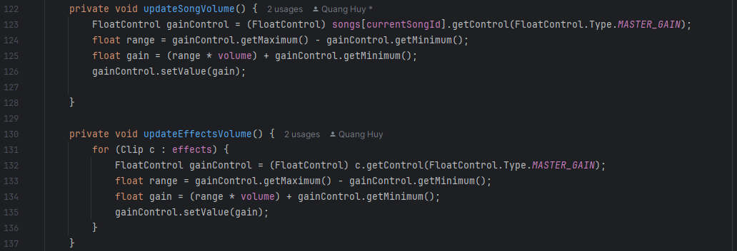

***“updateSongVolume”:*** This method adjusts the volume of the currently playing song based on the volume attribute.

* + ***“FloatControl gainControl = ...”:***
    - Retrieves a *“FloatControl”* object for the current song.
    - *“FloatControl.Type.MASTER_GAIN”:* Controls the overall gain (volume) of the audio clip.
  + *“float range = gainControl.getMaximum() - gainControl.getMinimum();”:* Calculates the range of the gain (volume control) in decibels (dB). This range is typically from a minimum negative value (e.g., -80.0 dB) to a maximum (e.g., 6.0 dB).
  + *“float gain = (range * volume) + gainControl.getMinimum();”:* Scales the current volume (a float between 0.0 and 1.0) to fit within the gain range and adjusts the value relative to the minimum gain.
  + *“gainControl.setValue(gain);”:* Sets the calculated gain value to adjust the song's playback volume.

***“UpdateEffectVolume”:*** Adjusts the volume of all sound effects in the effects array to match the current volume setting.

* + Loops through each Clip in the effects array.
  + Adjusting through effects: The same process as in updateSongVolume() is applied to each sound effect.
* **setVolume and stopSong (from line68 to line 77):**

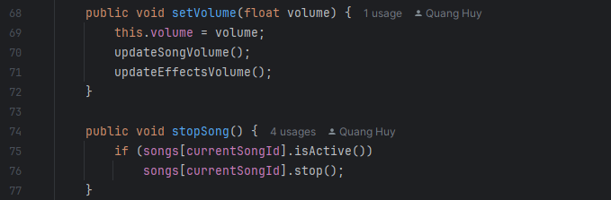

* ***“setVolume"* method:** This method allows adjusting the audio volume for both songs and sound effects.
  + *“this.volume = volume;”:* Updates the internal volume attribute of the class with the new value provided by the method parameter.
  + *“updateSongVolume();”:* Updates the playback volume for the currently playing song based on the new volume value.
  + *“updateEffectsVolume();”:* Updates the playback volume for all sound effects using the new volume value.
* ***“stopSong”* method:** This method stops the currently playing song.
  + *“if (songs[currentSongId].isActive())”:* Checks whether the song at the current currentSongId index is actively playing. This prevents unnecessary calls to stop a song that isn’t playing.
  + *“songs[currentSongId].stop();”:* Halts the playback of the active song. The stop() method resets the audio clip's position to the start.
* **playSong and playEffect (from line 79 to line 91):**

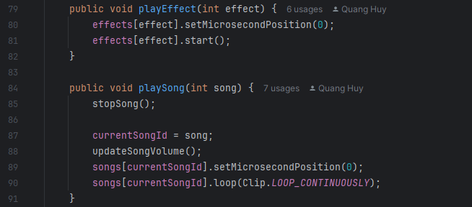

* + ***“playEffect”:*** This method plays a specific sound effect from the effects array.
  + ***“playSong”:*** This method is designed for playing background music and handles continuous playback.
* **toggleSongMute and toggleEffectMute (from line 93 to line 109):**

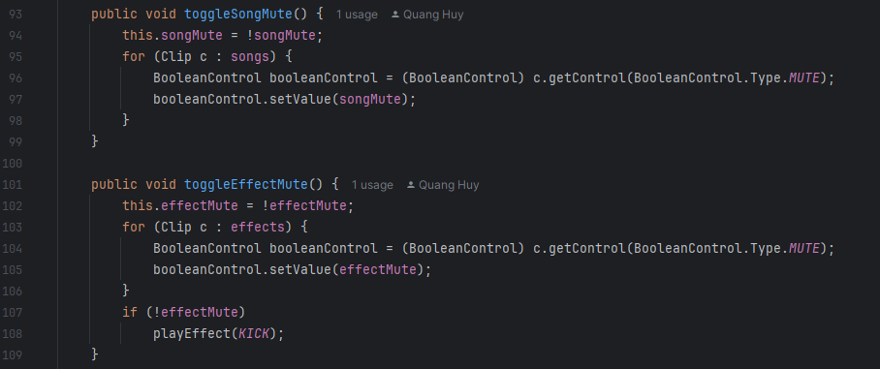

* ***“toggleSongMute”* method:** This method toggles the mute state for all background songs.
  + allows the user to mute or unmute all background music tracks dynamically.
  + Uses a BooleanControl object to manage the mute state.
* ***“toggleEffectMute”* method:** This method toggles the mute state for all sound effects.
  + Provides control over muting or unmuting all sound effects in the game.
  + Includes immediate feedback to indicate that sound effects are unmuted (via the "kick" sound.

1. **Menu:**
2. **Main Menu:**

**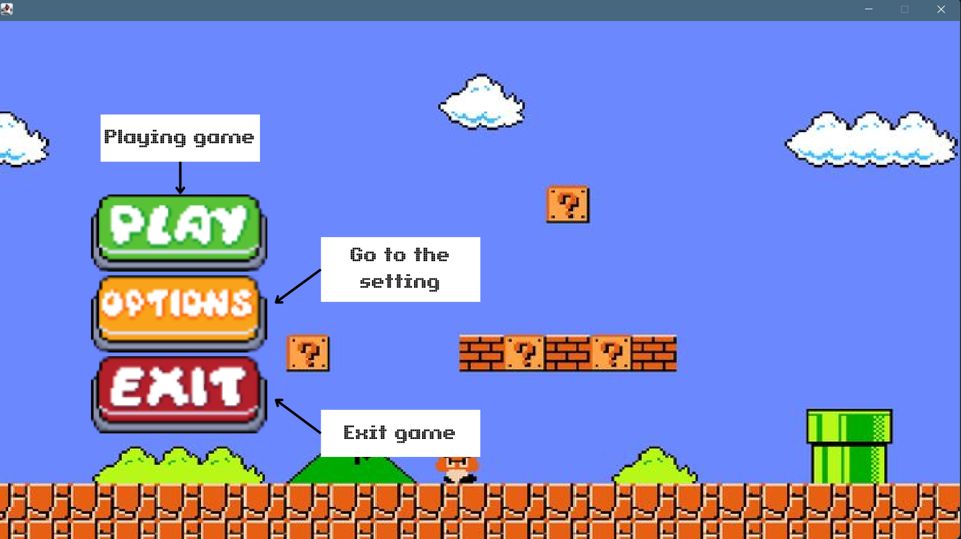  
Create a rectangle and load image inside the rectangle: (ui/Menubutton)**

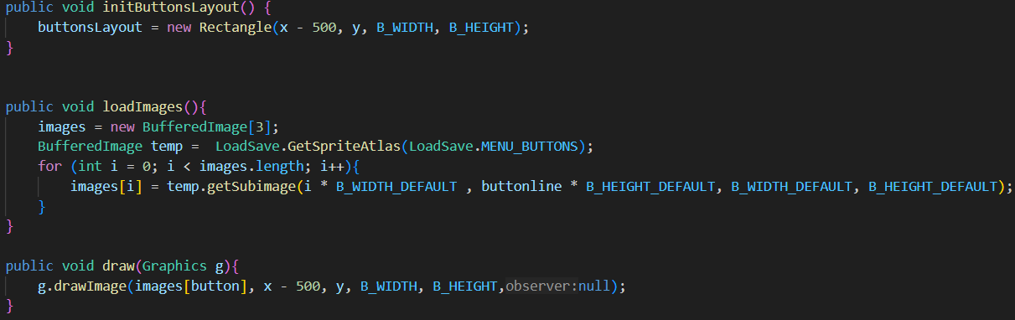

* As game condition diagram mentioned in 2.5, when starting the game, the condition is adjusted MENU so the MENU will display first.
* In MENU create background and menubutton:

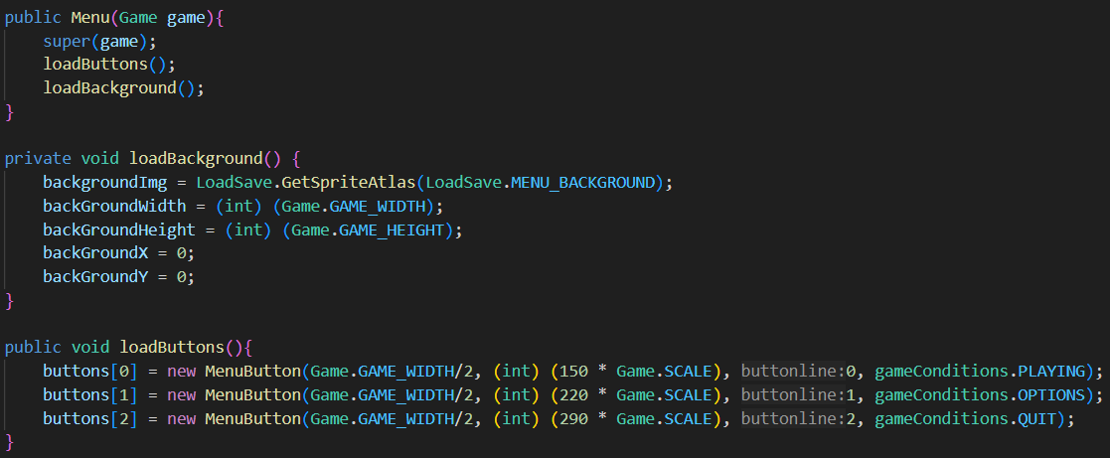

* When mouse move of press inside the buttons the method to change the image:

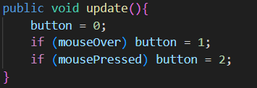

* Each button has different game condition so when they are pressed, they change to the others display (PLAYING, OPTIONS, QUIT).

1. **Main Menu:**

After clicking the option button, the game screen will display a setting for the sound and music of the game.

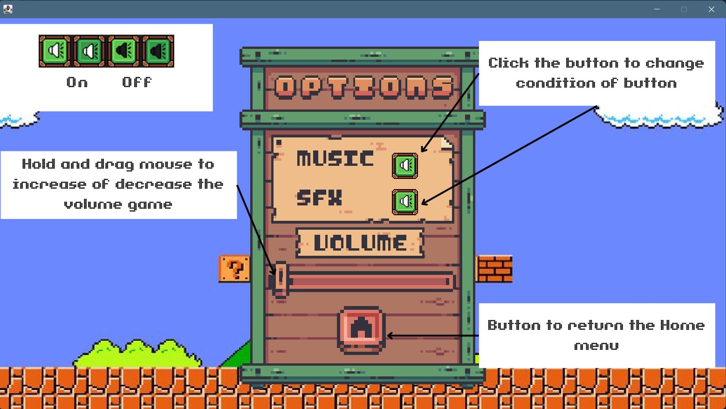

* The music button provides the ability to turn on or off music for the player.
* SFX button provides the ability to turn on or off the sound of actions (jumping, run, eliminate the enemies).
* Hold and drag volume button on the y-axis to adjust the levels of volume.
* Create the music button in ui.

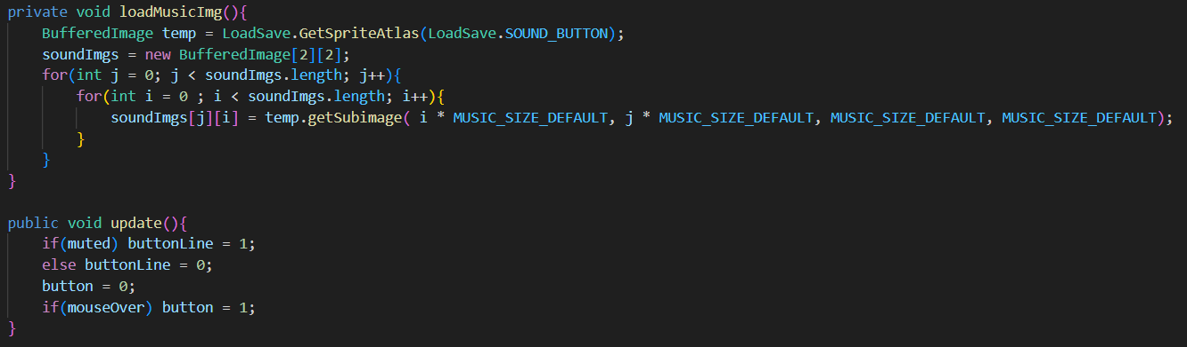

* Update to change the image the button when it is pressed.
* The color of the sound button distinguishes the condition music is on or off.
* Create the volume button:

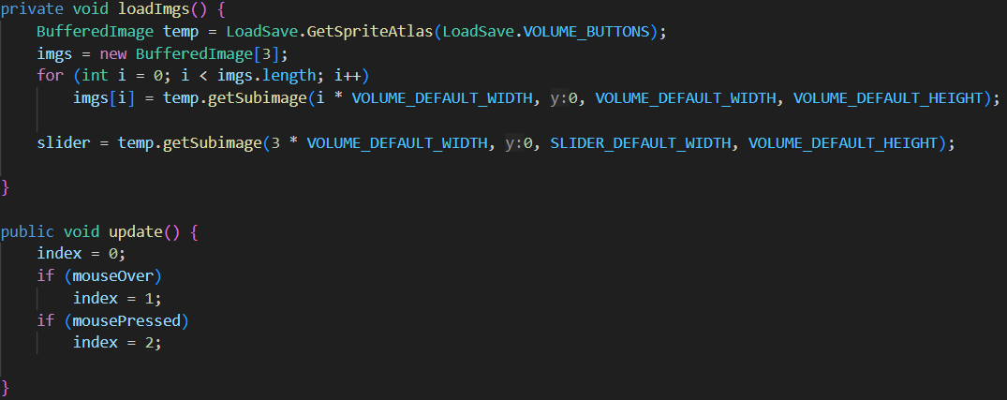

* They all have rectangle from pause buttons, so the volume only moves inside the imagine.

1. **Let’s play:**

Press “a” or “d” from keyboard to move out the starting position.

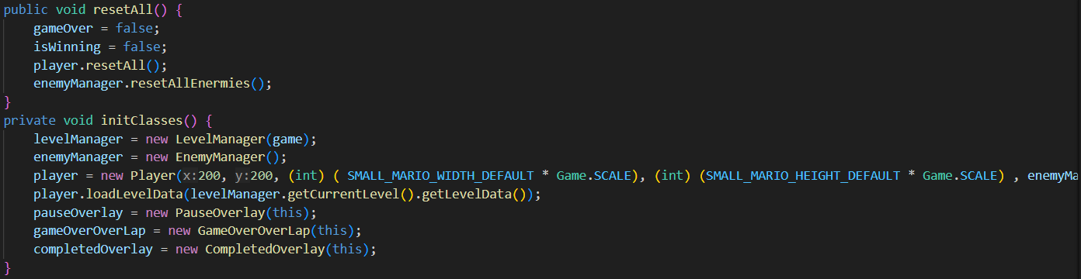

* Press space to jump (jump over obstacles like enemies and terrain).
* Jump on the head of enemies to eliminate them**.**
  1. **Death screem:**

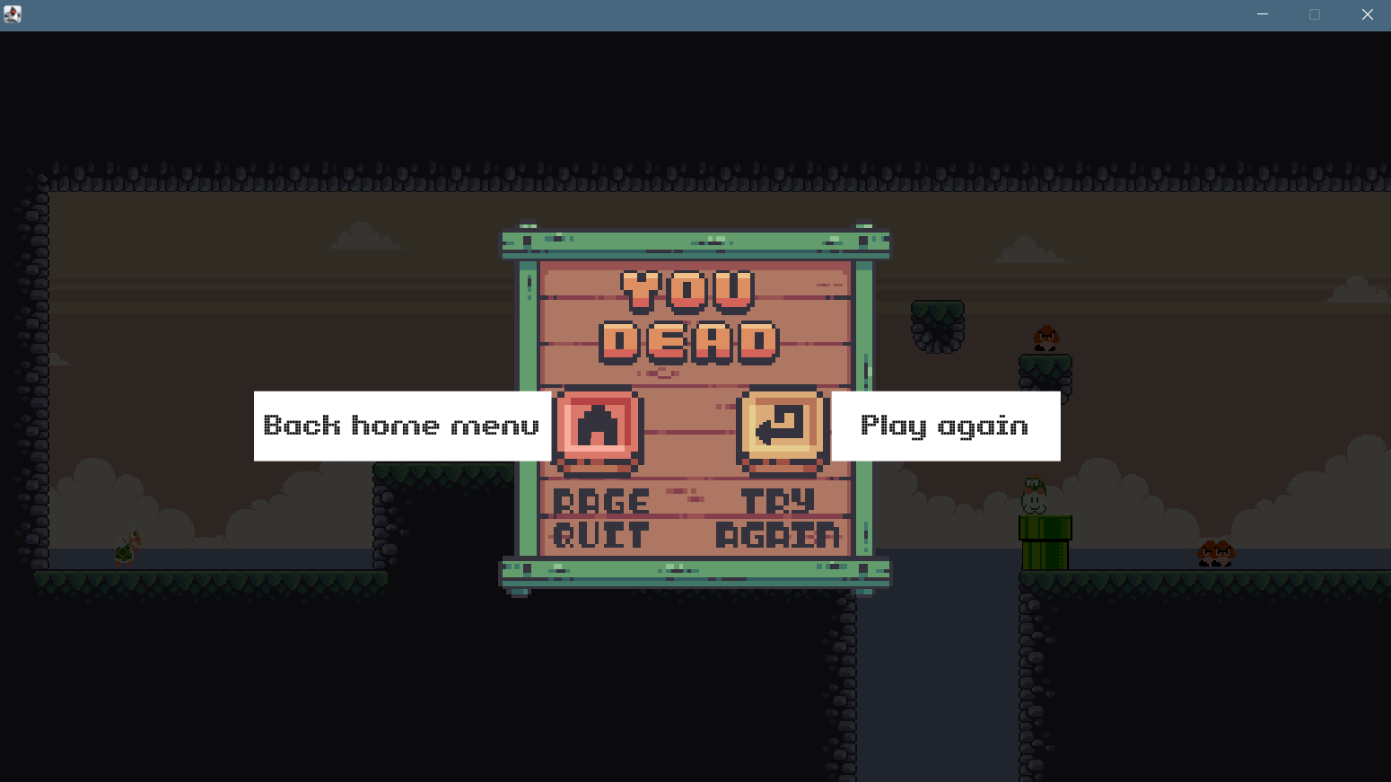

If you cannot hit the head of enemies or cannot jump over the hole. The character will be knocked out and the dead layout will appear after a second.

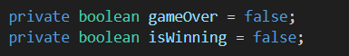

* The “gameOver” and “isWinning” here identity when game over display and is winning screen will appear.
* Pressing the try again button will respawn all the enemies and the character at the starting position.
* These buttons have created in packet user interface

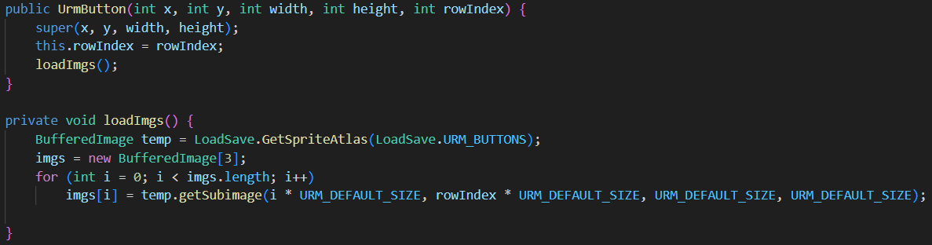

* 1. **Pause screen:**

Press “ESC” on keyboard to pause game anytime the character is alive.

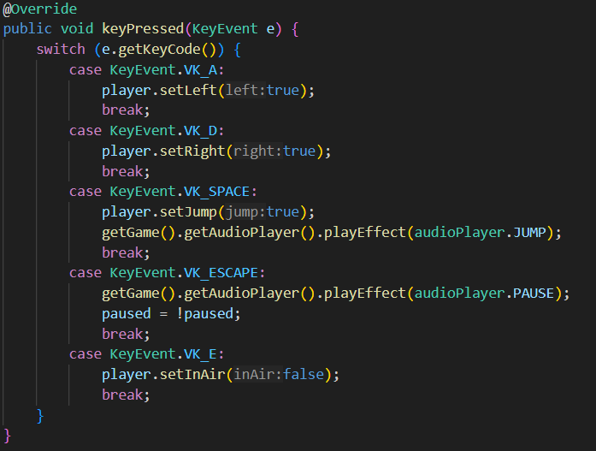

* The music buttons and volume button load from sound options class to synchronous with buttons from OPTION condition**.**

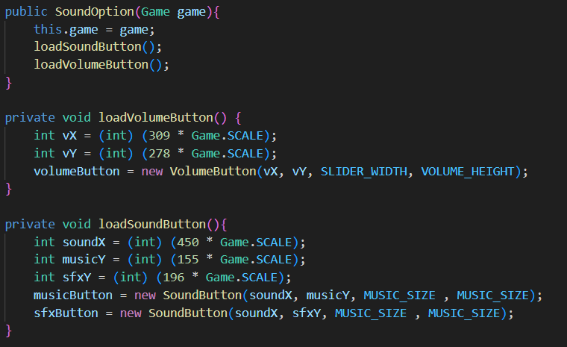

* Three buttons to replay, continue, and go back to MENU are created in user interface packet (ui).

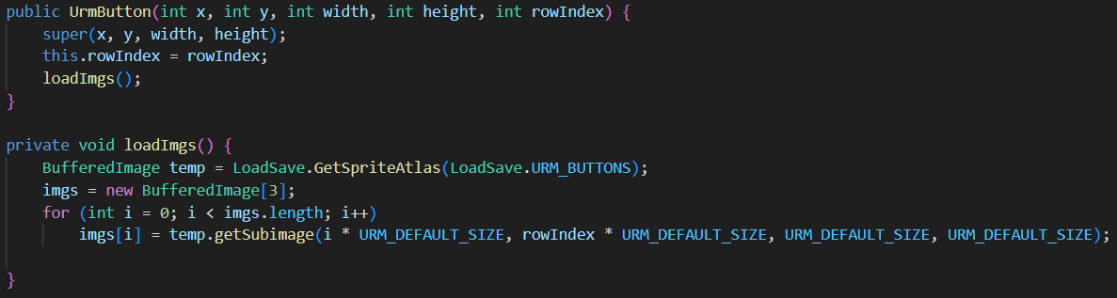

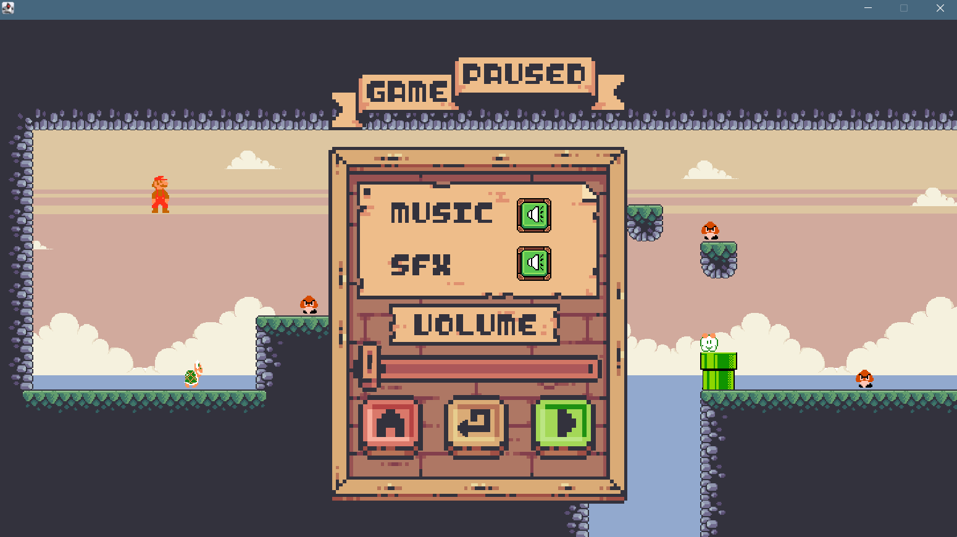

* 1. **Victory screen:**

- When you touch the flag at the end of map this screen will appear.

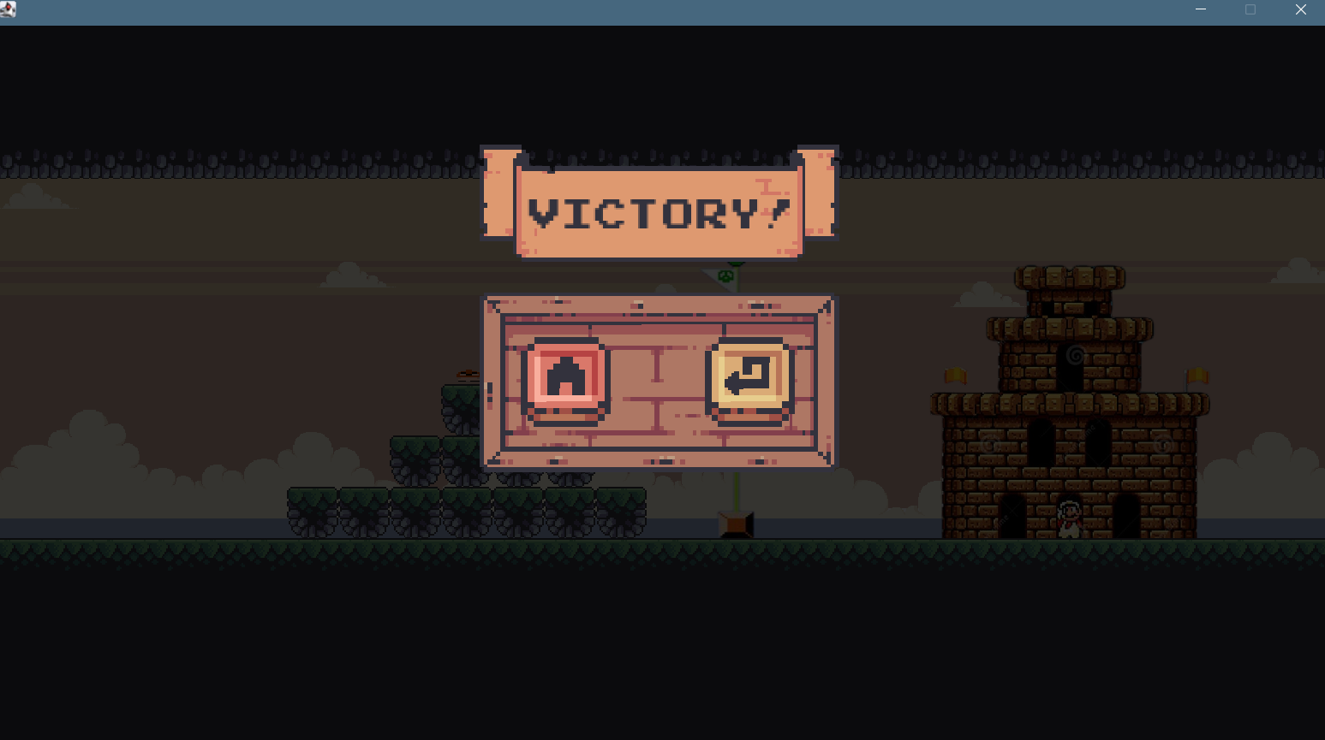

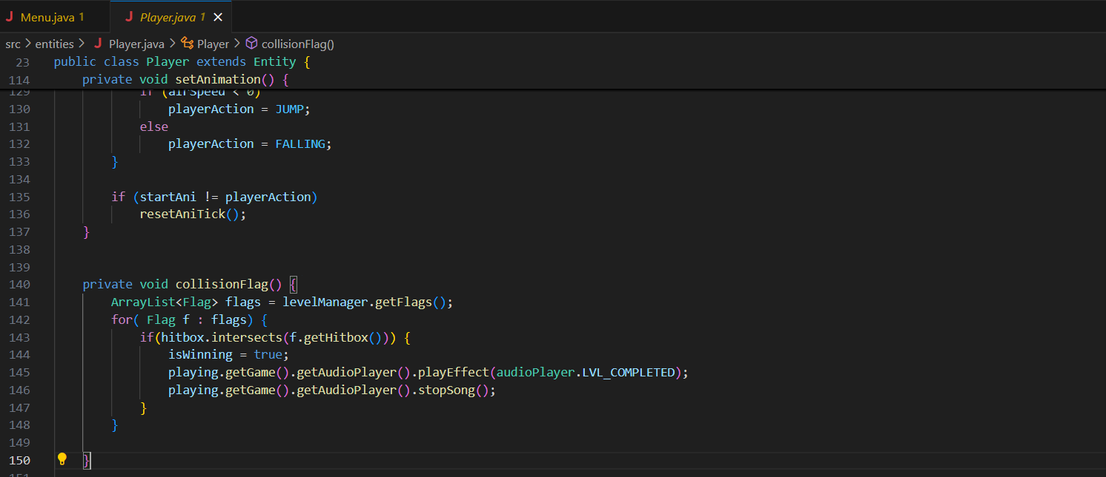

* Create a box ~ rectangle for Flag image then when character reach the hitbox the winning layout will appear.
* There are back to menu button and replay button. These buttons also from button have applied in pause menu, game over interface, and OPTION menu.

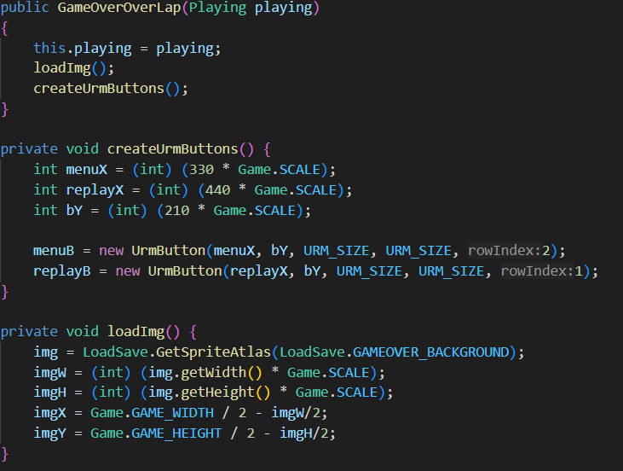

* Create buttons from ui/urmbutton which have applied in MENU, OPTION, PAUSE and DEATH_DISPLAY.

# CHAPTER 4:

# TASK ALLOCATION & CONTRIBUTION

# **CONTRIBUTION**

|  |  |  |
| --- | --- | --- |
| **Name** | **Student ID** | **Contribution** |
| Nguyễn Tấn Khánh | ITCSIU23014 | 26% |
| Lê Hoàng Khanh | ITCSIU23013 | 24.5% |
| Trần Quang Huy | ITCSIU23038 | 25% |
| Phạm Trung Kiên | ITCSIU23020 | 24.5% |

# 

# **TASK ALLOCATION**

# 

|  |  |  |
| --- | --- | --- |
| **STAGE** | **ACTION** | **MEMBER** |
| **PLANNING****AND PREPARATION** | Researching about the project topic, analyzing the project requirements | **All member** |
| Looking for image, sound, animation | **All member** |
| **DESIGNING UML** |  | Khanh |
| **CODE** | User interface menu | Kiên |
| Player animation and level data | Khánh |
| Collision and gravity | Huy |
| Enemy (Turtle, Mushroom, Joker) | Khánh, Khanh |
|  | Audio | Huy |
|  | Playing menu (Dead, Victory, pause) | Kiên |
| TESTINGAND COMPLETING THE REPORT | Fixing bugs on Java | Khánh, Huy |
| Testing functions of application and optimizing the application performance | Khánh, Huy |
| Writing Final Report | All member |
| Making slides for the presentation | All member |
| Rehearsing the presentation and reviewing the overall project | All member |
| PRESENTATION |  | All member |

# 

# 

# 

# 

# - END -

# 